DEFINE CHEMISTRY
- Chemistry is the study of structure and composition of substances and the way they behave under different conditions
BRANCHES OF CHEMISTRY
Explain six branches of chemistry.
There are six branches of chemistry and these include

Branch of chemistry | Description | Example
Analytical Chemistry | The study of the separation, identification and quantification of the chemical components of natural and artificial materials | Food processing industry
Industrial Chemistry | The study of the application of physical and chemical processes towards the change of raw materials into beneficial products | Manufacturer of painkillers like panadol
Organic Chemistry | The study of the compounds of carbon apart from the oxides and carbonates. | Distillation of crude oil.
Inorganic Chemistry | The study of properties of materials from non-biological origins | Fertilizer’s composition.
Physical Chemistry | The study of how chemical compounds and their constituents react and interact with each other. | Separation of coloured substances
Environmental Chemistry | The study of chemical process  occurring in the environment which are impacted by human activities | Pollution of air, soil and water
IMPORTANCE OF CHEMISTRY IN EVERYDAY LIFE
The following are examples of application of chemistry include
- When baking powder is added to doughnut or bread and the mixtures baked in a hot oven, the rising of the bread can be explained in chemistry.
- In the manufacture of soap and other detergents Chemistry is applied.
- Chemistry is applied in the manufacture of drugs such as panadol. Such drugs are used in homes and hospitals.
- Chemistry is applied in cooking in cooking especially in mixing of ingredients while making a cup of tea and preparation of nsima.
- The processing of crude oil
- Discovery, testing and release of new drugs into the market.
CHEMISTRY AND CAREER CHOICES
Mention six careers one can purse after studying chemistry.
The following are examples of chemistry and career choices
- Chemical engineers
- Medical nurses
- Chemistry teachers
- Beauticians
- Vertinary officers
- Medical doctors
- Pharmacists.
- Geochemists
- Biochemists
- Food chemists
- Photo chemists

LABORATORY SAFETY RULES
State five laboratory rules.
The following are safety rules include:
- Do not enter the laboratory without the teacher’s permission.
- Enter the laboratory in an orderly manners;
- Do not rush as you enter the laboratory or scramble for the front bench.
- Avoid unnecessary movement in the laboratory
- Do not perform unauthorized experiments.
- Do not taste any of the chemicals even those that you think are harmless.
- Do not tamper with electrical, gas or water fittings. Always turn off water taps and gas taps when not in use.
- Do not smell gases directly. Hold the gas source about 15-20cm from the nose and waft the gas towards the nose with your palm.
- Never interfere with other students’ experiments left in progress in the laboratory.
- Never boil a liquid while facing the test tube towards yourself, friends or books in case of spurting.
- Keep naked frames from inflammable substances especially volatile liquids or solutions.
- If chemicals get into contact with your clothes, skin, eyes or mouth, wash the affected area with plenty of water immediately.
- In case of a burn or a cut, report the accident to the teacher or laboratory technician immediately.
- Read the label on all reagents before you use them.
- Do not put hot materials into the waste containers.
- All solid waste should be properly disposed of. Do not pour insoluble materials into the sinks.
- Read and follow instructions carefully before you perform any experiment.
- All experiments that emit poisonous gases should be performed in a fume chamber, or open space.
- After finishing with a reagent bottle, replace the stopper and store it in its proper place.
- Always clean all the apparatus and bench tops after use. Wash your hands well before leaving the laboratory.
- Do not move anything out of the laboratory unless authorized.
HOW CAN YOU PROTECT YOURSEF WHEN PERFOPRMING EXPERIMENTS
When performing experiments you must protect yourself by
- Wearing a laboratory coat to protect your clothes from dirt and chemicals.
- Wearing plastic gloves to protect your eyes from solid particles or splashing liquids.
- Wearing plastic goggles to protect your hands from corrosive chemicals.
- Holding hot objects with holders for example a pair of tongs or improvised holders like folded paper.
- Tying long hair at the back.
- Preparing irritating gases in the fume chamber or open space.
APPARATUS
Apparatus refers to the set of equipment used by chemists to do their work.
Laboratory apparatus can be put into various categories as follows
- Measuring apparatus.
- Heating apparatus
- Other apparatus.
In chemistry, different apparatus are used to measure volume, mass, temperature and time.
APPARATUS FOR MEASURING VOLUME
- MEASURING CYLINDERS
Measuring cylinders may be made of glass or plastic.
Uses of measuring cylinders
Measuring cylinders are used for measuring approximate volumes of liquids or solutions. Figure below shows measuring cylinders of different capacities
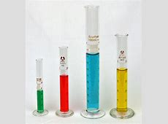
- BURETTE
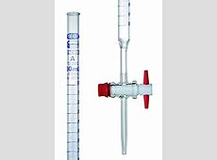
A burette is used for measuring accurate or exact small volumes of liquids or solutions during chemical analysis.
- PIPETTE
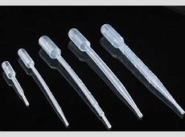
A pipette is used for transferring or measuring small exact quantities of liquids or solutions during chemical analysis.
- VOLUMETRIC FLASK
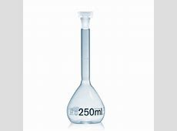
A volumetric flask is used to measure accurate volumes of liquids or solutions. They have different capacities.
APPARTUS FOR MEASURING MASS
- BEAM BALANCE OR ELECTRONIC BALANCE
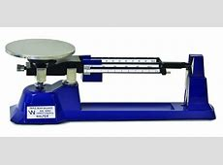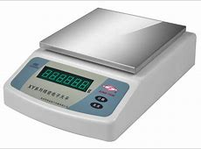
Beam balance Electronic balance
A beam balance or electronic balance is used to measure accurate masses of substances. Balances measure mass of substances in grams(g) or kilograms (kg)
APPARATUS FOR MEAURING TEMPERATURE
THERMOMETER
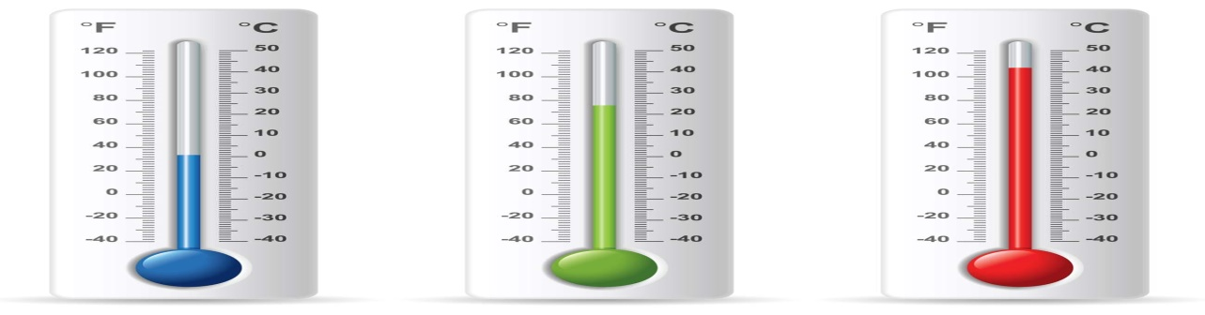
Mercury bulb
A thermometer is used to measure temperature. Examples of thermometers are mercury and clinical thermometer which is shown below.
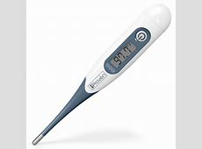
Clinical thermometer
APPARATUS FOR MEASURING TIME
STOP WATCH
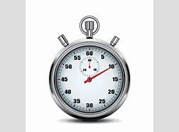
A stop watch or clock is used to measure time.
OTHER APPARATUS
- TUBES
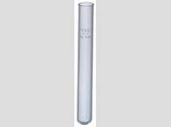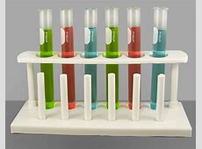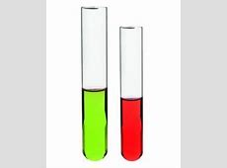
IGNITION TUBE TESTUTUBES BOILING TUBE
Ignition tubes are used for decomposition of compounds by strong heating, ordinary test tubes are used for heating substances, and boiling tubes are used for boiling small amounts of liquids or solutions.
BEAKERS
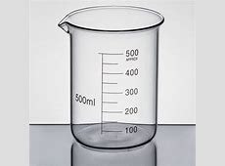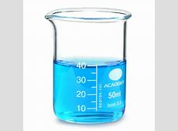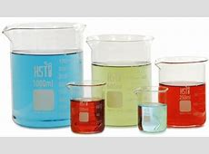
Beakers have many uses such as boiling liquids or solutions if they are made of glass and holding the liquid or solution.

FLASKS
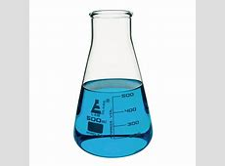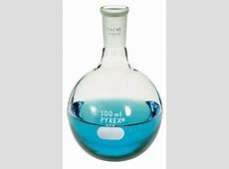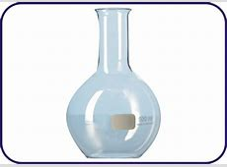
CONICAL FLASK ROUND-BOTTOM FLASK FLAT-BOTTOM FLASK
Flasks are usually used to hold liquids or solutions when heating and reactions where heat may be liberated.
A GAS JAR
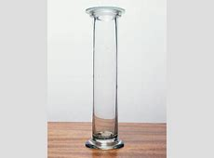
Gas jars are used to collect gases and are prepared in the laboratory. They are usually covered with glass covers to prevent a light gas from escaping.
EVAPORATING DISH
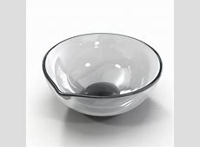
Evaporating dishes are used to evaporate water from solutions in order to recover the dissolved solid substance (solute). They are usually made of porcelain.
DEFLAGRATING SPOON
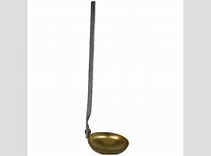
A deflagrating spoon is used to hold substances when burning them in air or in gas jars.
SPATULA
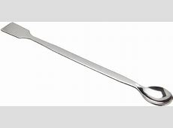
A spatula is used to scoop small quantities of solid chemicals from a container.
TONGS
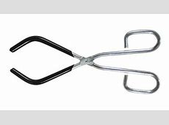
Tongs are used to hold crucible or crucible covers.
TRIPOD STAND
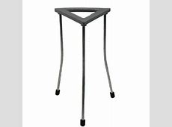
A tripod stand is used to support apparatus like beakers when boiling or heating a liquid.
WIRE GAUZE
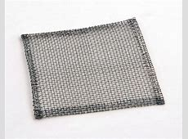
A wire gauze is usually placed on the tripod stand to hold beakers when boiling liquids.
STAND AND CLAMP
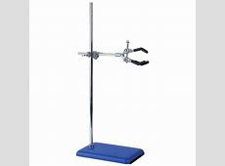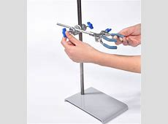
A stand is used to mount apparatus, whereas a clamp is used to hold burettes and other apparatus when doing an experiment.
LIEBIG COONDENSER
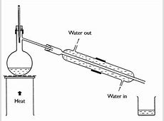
This apparatus cools the vapour as it passes the centre of the condenser during distillation when separating miscible liquids.
THISTLE FUNNEL
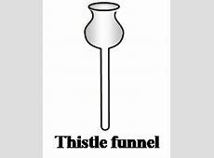
This is used to add liquids into flask at once.
DROPPING FUNNEL
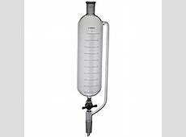
Dropping funnel is used to add liquids or solutions into flasks in small quantities.
SEPARATING FUNNEL
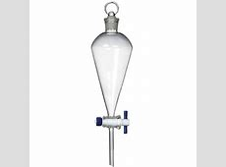
Separating funnel is used to separate immiscible liquids.
FILTER FUNNEL
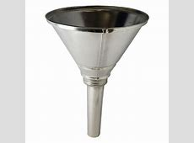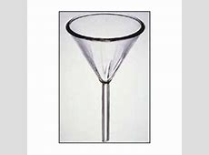
Filter funnel is used to pour liquids into containers with small mouths and also to filter solutions containing undissolved solids. A filter paper is placed inside the funnel to hold undissolved material.
DROPPER OR TEAT PIPETTE
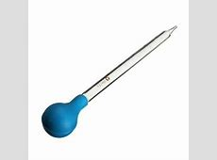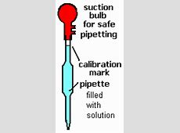
A dropper is used to deliver a little liquid when required in drops into another container.
HEATING APPARATUS
SPIRIT LAMP
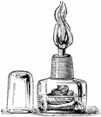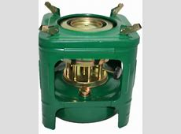
Spirit lamp Kerosene
Spirit lamp and kerosene are used for heating liquids.
THE BUNSENER BURNER
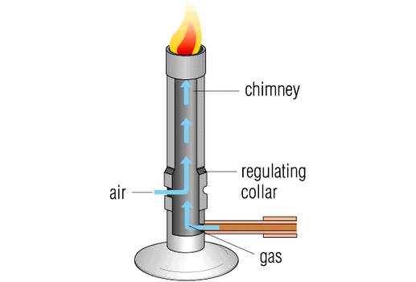
The Bunsen burner was invented in 1854 by a German chemist called Robert Wilhelm Bunsen. This is how it derived its name.
It is used for heating liquids in the laboratory.
HAZARD SYMBOLS AND THEIR MEANINGS
- EXPLOSIVE
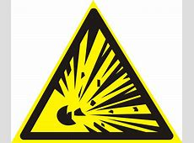
Explosive substances can detonate any time. Chemicals bearing the explosive sign should be handled carefully and according to instructions.
- TOXIC SYMBOL
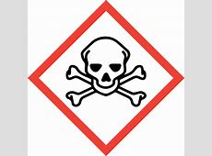
Toxic substances are poisonous. They can cause death. So if any chemical pours on your skin accidently wash it with a lot of water. Watch out toxic substance sign.
- OXIDISING SYMBOL
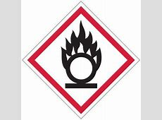
There are some substances which can explode in the presence of an oxidizing agent.
- CORROSIVE SYMBOL
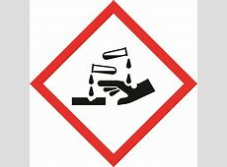
There are some chemicals which can burn your skin. They corrode bench tops, metals and floors. Pour water on any chemical that you may pour on the benches accidently to make it less corrosive.
- FLAMMABLE SYMBOL
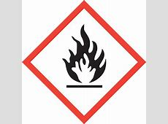
There are some chemicals that evaporate easily and catch fire very easily. They should never be brought near open flames. Once they are removed from the bottle, the bottle must be stoppered immediately.
- IRRITANT
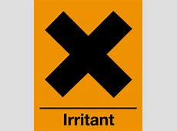
Irritant or harmful substances make you sick or endanger your health. They can endanger your health if they come in contact with your skin or eyes for too long. People who are asthmatic should be extremely careful to avoid inhaling such substances.
Explain why most of the apparatus used in the laboratory are made of glass.
Most of the apparatus used in the laboratory are made of glass so can see what is happening when doing experiments.
COMMON UNITS OF MEASUREMENT
THE SI UNIT
The SI system is an international system of units and it is accepted worldwide and the units are used to express quantities.
Each quantity has an SI unit and each unit has a symbol. For example the quantity of mass has a unit of either kilogram with symbol (kg) or gram with the symbol (g).
REPRESENTATION OF PHYSICAL QUANTITIES\
Physical quantity numerical value unit
(Show how many times the
unit is contained in a given
quantity)
Mass =10 kilograms
The above information is written simply as 10kg.
Physical quantity is represented by a letter-symbol and the unit in unit-symbol which it is measured.
Symbols reduce words to letters just as the names of elements and compounds are reduced to symbols and formulae respectively when dealing with elements.
Physical quantity refers to the measurement you want to take.
TABLE 1 BASIC SI UNITS OF VARIOUS QUANTITIES
Physical quantity  (measurement) | Name of SI(base) | Symbol of SI Unit
Length | metre | m
Mass | kilogram | kg
Time | second | s
Temperature | kelvin | K
The SI rules demand that the symbol should neither be followed by full stop nor should be in plural of the mass of a substance. For, example, ten kilograms is abbreviated as 10kg not 10kg. or 10kgs.
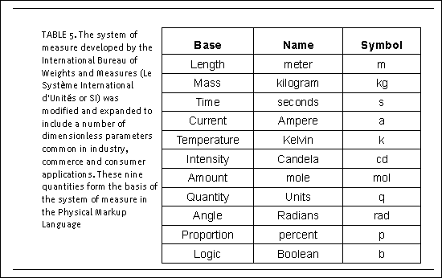
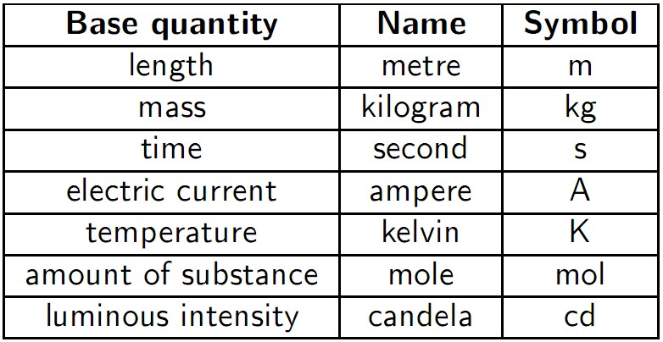
Give the names of basic SI unit and symbols for the following physical quantities; length, time, area, density, temperature and amount of substance.
Derived quantity | Derived SI unit name | Symbol
Area | Square metre | $$m^{2}$$
Density | Kilogram per cubic metre | kg$/m^{3}$
Amount of substance  (concentration) | Moles per cubic metre | mol$/m^{3}$
DERIVED UNITS
Define derived physical quantities
These are physical quantities obtained by combining (dividing or multiplying) one or more of the basic physical quantities.
Amount of substance | mole | mol
Electric current | ampere | A
Luminous intensity | candela | cd
Plane angle | radian | rad
Solid angle | steradian | sr
Define derived physical quantities
These are physical quantities obtained by combining (dividing or multiplying) one or more of the basic physical quantities.
Differentiate between based and derived units of measurements.
Base unit (measurement)
A base unit (also referred to as a fundamental unit) is a unit adopted for measurement of a base quantity. A base quantity is one of a conventionally chosen subset of physical quantities, where no quantity in the subset can be expressed in terms of the others.
Derived units are units of measurements (for derived quantities) which are derived from base units of the component base quantities by multiplication or division or both. In the case of the derived quantity, speed, its derived unit is metre/time (with unit symbol, m/s or m s-1)
TABLE 2 SOME SI DERIVED UNITS EXPRESSED IN TERMS OF BASE UNITS
Name the derived units and indicate their symbols or give the names of basic SI unit and symbols for the following physical quantities; length, time, temperature and amount of substance.
Derived quantity | Derived SI unit name | Symbol
Area | Square metre | $$m^{2}$$
Density | Kilogram per cubic metre | kg$/m^{3}$
Amount of substance  (concentration) | Moles per cubic metre | mol$/m^{3}$
What physical quantities do the following SI symbols represent?
- s b. K c . kg d. mol
S | Time
K | Temperature
kg | mass
mol | amount
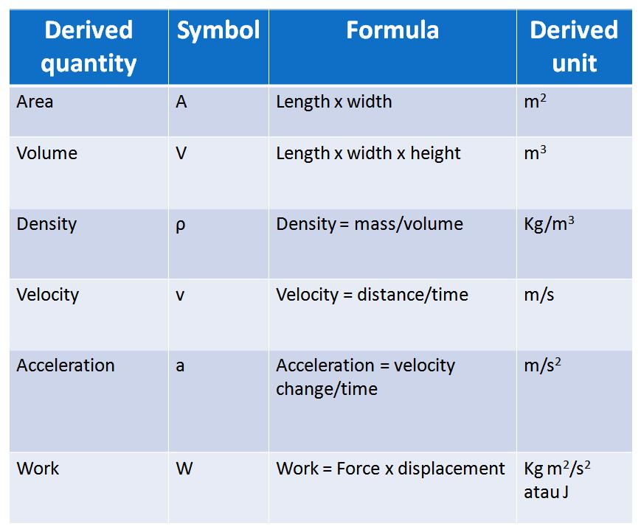
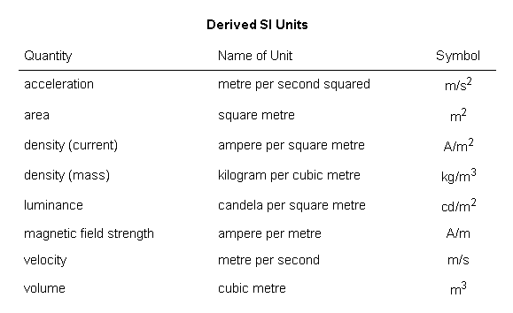
SI PREFIXES
Working with SI unit gives challenges when dealing with very large number or very small values. For example, one mole of a substance contains approximately 6.0 x ${10}^{23}$ particles of substance. Imagine counting 6.0 x ${10}^{23}$ particles. How many days would it take?
In order to accommodate some very large numerical values and some very small value, multiple of units in powers of ten are indicated by means of agreed prefixes and their sizes as multiples of ten in other words, some agreed prefixes are used as micro, mega among others.
EXAMPLES SOME PREFIXES AND THEIR SIZES AS MULTIPLES OF TEN
Name examples of preifixes used for very small and very large numerical values
Multiple (power of 10) | Meaning (in metres) | Prefix | Unit
$${10}^{-6}$$ | 0.000,001 | micro | micrometre
$${10}^{-9}$$ | 0.000,000,001 | nano | N
$${10}^{3}$$ | 1,000 (Thousand) | Kilo | K
$${10}^{6}$$ | 1,000,000(Million) | mega | M
$${10}^{9}$$ | 1,000,000,000(Billion) | giga | G
$${10}^{12}$$ | 1,000,000,000,000(Trillion) | Tera | T
SCIENTIFIC METHODS OF INVESTIGATION
People who studied chemistry in the 18th century had very few apparatus to use.
Scientific methods of investigation in research lead to new discoveries of substances in Chemistry.
They were kind of speculative philosophers whose main aims were:
- Transmission (change nature) of base metals like copper, iron and silver to gold.
- To discover universal cure of diseases.
- To discover means of prolong life indefinitely.
STEPS TO BE CARRIED OUT WHEN CARRYING OUT AN INVESTIGATION
- State the question - What is it that you want to find out? The question may refer to the explanation of a situation or a specific observation you made.
- Research on the topic- Read to find out what chemists have investigated and learned about the topic.
- State the hypothesis- Predict using available information, what you think will happen on testing or in the experiment. This guess must be stated and proved right or wrong by experimentation.
- Testing the hypothesis- Design an experiment or method for testing if the hypothesis is true or false.
- Analyse the results- This involves examining the data collected and determining what the results of the experiment show. Do the results support the hypothesis?
- Draw conclusion- If the results of the experiments come out as predicted, the hypothesis will be accepted as being collect.
However, if the results do not come out as predicted, the hypothesis will be rejected as false. This means that another hypothesis is required. A new question can be asked on the same topic and investigation repeated.

UNIT TWO: ESSENTIAL MATHEMATICAL SKILLS FOR CHEMISTRY
STANDARD FORM AND SCIENTIFIC NOTATION
Standard form (scientific notation) is defined as the way that scientists write numbers that are two big or two small.
Scientific notation is a convenient method of expressing large and small numbers in exponential form (that is, in powers of ten)
EXAMPLE
- The Avogadro’s constant 602,300,000,000,000,000,000,000 is expressed in scientific notation as 6.023 x${10}^{23}$.
The notation.023 x ${10}^{23}$ tells us to multiply 6.023 by 10 twenty-three times.
The first (6) is called the digit term which is a number greater than one but less than ten.
The second number (.023)is called the exponential term and is written as 10 with an exponent (10 raised to a power n where n is a whole number, that is, ${10}^{n}$)
- The speed of light 30,000,000,000cm per sec is expressed in scientific notation as 3.0 x ${10}^{10}$.
The notation 3.0 x${10}^{10}$. tells us to multiply 3.0 by 10 ten times.
- The mass of an electron : 0.000,000,000,000,000,000,000,000,000,911g,es expressed in scientific notation as 9.11 x ${10}^{-28}$g.
The notation 9.11 x ${10}^{-28}$g tells us to divide 9.11 by 10 twenty -eight times.
- The co-efficient of expansion of copper 0.0000167 is expressed in scientific notation as 1.67 x ${10}^{-5}$.
The notation 1.67 x ${10}^{-5}$ tells us to divide 1.67 by 10 five times.
CHANGING NUMBERS TO STANDARD FORM
- To convert large normal numbers to standard form you have to put a decimal point after the first digit and ignore the zeros at the end (if there is another number that is not 0 after the zero(s), don’t ignore them).
Example
- The distance of the earth from is moon is 384,400,000 metres. Convert the distance of the earth from the moon in standard from.
384,400,000 = 3.844 x ${10}^{8}$
Explanations
In the example above, you should end up with 3.844. Then, you have to count the digits from the right to the left until you reach your decimal point. In the example, there are 8 digits on the right side of the decimal point. This will be your power. When you write down the answer, you will get 3.844 x ${10}^{8}$. The 3.844 being the decimal we calculated earlier and the 8 being the number of digits to the decimal point
- Convert 490,000,000 to standard form.
In standard, 490,000,000 becomes 4.9 x ${10}^{8}$
- To convert small normal numbers into standard form, you have to find the first non 0 digit after the decimal point. After this digit, you place your new decimal point ignoring everything that is in front of this digit.
Example
Convert 0.00000000567g to standard form.
Answer
0.00000000567g to standard form becomes 5.67 x ${10}^{-9}$
In the example above, the digit would be 5 and the decimal would be 5.67. The only thing that you have to do now is to count how many digits there are between the original decimal point and the new (imaginary one). In this case, there are 9 digits so the final answer would be:
5.67 x ${10}^{-9}$ .
Write these numbers in standard form
- 0.00423 = 4.23 x ${10}^{-3}$ (move the decimal point to right)
- 987000 =9.87000 x ${10}^{5}$ (move the decimal point to left)
- 9028 = 9.028 x ${10}^{3}$
- 8 = 8 x ${10}^{0}$
- 0.008 = 8 x ${10}^{-3}$
- 0.000456 = 4.56 x ${10}^{-4}$
RULES OF WRITING NUMBERS IN ORDINARY NOTATION
- Multiplying a digit term by a positive power of 10 moves the decimal point that number of places to the right:
Examples of scientific notation with digit terms multiplied by positive powers of 1o written as numbers:
- 1.23 $×$ ${10}^{4}$ = 12300
- 9.46 $×$ ${10}^{7}$ = 94,600,000
- 7.29 $×$ ${10}^{2}$ = 729
- Multiply by ${10}^{-n}$ where n is negative, move the decimal point ($°$) the number of placces indicated by the value of n to the left.
Examples of scientific notations when the value of n is negative number:
- 2.56 $×$ ${10}^{-1}$ or 2.56 $×$ $\frac{1}{10}$ = 0.256
- 6.42 $×$ ${10}^{-2}$ or 6.42 x $\frac{1}{{10}^{2}}$ = 0.0642
- 5.745 $×$ ${10}^{-5 }$ or 5.745 x $\frac{1}{{10}^{5}}$ = 0.00005745
Write out these numbers in ordinary notation.
Ordinary notation
- 8.96 x ${10}^{-4 }$ = 0.000896
- 3.2 x ${10}^{6 }$ = 3200000
- 1.6 x ${10}^{2 }$ = 160
- 1.1 x ${10}^{o }$ = 1.1
SIGNIFICANT FIGURES
A significant figure is a digit in a number that shows how the number is nearer to its exact value.
When a number is rounded off, the significant or important figures are not changed. For example, 14728 rounded off to 3 significant will be 14700. In this case 1, 4 and 7 are the 3 significant figures.
The scientific notation (standard numbers) in a measurement eliminates the confusion that sometimes occurs as to whether or not zeros in a number are significant.
Example
Avogadro constant 602,300,000,000,000,000,000,000 written in
standard form as 6.023 x ${10}^{23}$ shows that the number has four significant figures. Thus the zeros present in the figure above are not significant.

Example
The co-efficient of expansion of copper 0.0000167 written in standard form as 1.67 x ${10}^{-5}$ shows the number has three significant figures. Thus the zeros present in the figure above are not significant
Explanation
In any number, the first non-zero digit is the first significant figure. The zeros in the above examples are needed only to locate the decimal point and are, therefore, not significant.
A zero will be counted as a significant figure if it comes in between other digits or appear after digit numbers written after occurrence of a decimal point.
Example
The figure 1.907cm has four significant figures the “0” is counted as a significant figure because it is in between numbers. Written in standard form, it will be 1.907 x ${10}^{0}$.
Example
The figure 0.0090 has two significant figures, that is, figure ‘9’ and ‘0’ after figure 9.
The reason being the zeros that appear after digit numbers written after a decimal point are significant. Written in standard form it will be 9.0 x ${10}^{0}$.
Example
75,000cm contain 5 significant figures. The zeros are all significant since they are not meant to locate the decimal point. The last zero in this case indicates an estimate made to 0.001cm.
SIGNIFINAT FIGURE RULES
- Non-zero digits are always significant.
Example
1976 has 4 significant figures while 1.24 has three significant figures.
- All zeros between other significant figures are significant.
Example
10078 has 5 significant figures.
10.02 has 4 significant figures
- The number of significant figures is determined with the left most non-zero digit.
0.00789203
The zeros on the left hand side are not significant.
The left most non-zero digit of a decimal figure is usually the most significant in this case 7 is the most significant. The zero between digit ‘2’ and ‘3’ is significant.
- The right most digit of a chemical figure is usually the least significant figure.
Example
0.00534 the digit ‘3’ is the least significant figure
- In a figure without a decimal point, the right most non-zero digit is the least significant figure.
Example
7900, the least significant figure is ‘9’
- Zeros are significant only if they are not being used exclusively to locate the decimal point.
APPLICATION OF UNITS OF MEASUREMENT
Define the following terms
- Area
This is the dimension that is derived by multiplying by the fundamental dimension of length and width.
Area = Length x Width
Since the SI unit of length is metre, the derived unit of area is therefore square metres as shown
m x m = $m^{2}$
The commonly used unit of length in Chemistry is the centimeter, the derived unit of area using centimeter units is square metres as shown
cm x cm = ${cm}^{2}$
- Volume
It is a three dimensional quantity that is used to characteristise states of matter.
Volume is obtained by multiplying unit of length by width and by height
Volume = L X W X H
- Density
Density is a derived quantity that relates the mass of a substance to its volume.
Density = $\frac{Mass of a substance}{Volume}$
- Molarity
Molarity = $\frac{number of moles of a substance}{Volume}$
Examples
- An iron rod weighing 55.81g is placed in a graduated measuring cylinder containing 50.0${cm}^{3}$ of water. The new water level is 57.1${cm}^{3}$. What is the density of the iron?
Density = $\frac{Mass of a substance}{Volume}$
Volume of iron = 57.1${cm}^{3}-$50.0${cm}^{3}$
=7.1${cm}^{3}$
= $\frac{55.81g}{7.1{cm}^{3}}$
= 7.86g/${cm}^{3}$
- Rectangular piece of bronze is 7.0cm long, 5.0cm wide and 2.0cm deep. Calculate the volume of the bronze.
Volume = L x W X H
= 7.0cm X 5.0cm x 2cm
= 70.0${cm}^{3}$
GRAPHS
Graphs are visual representations of data values measured in an experiment. They can be in form of line graphs, bar graphs, or pie charts.

UNIT THREE
COMPOSITION AND CLASSIFICATION OF MATTER
Define matter
Matter is defined as anything that has mass and occupies space.
In other words, matter are things which can be seen, tested, smelt or felt or anything that occupies space and possess mass.
Examples of matter include a pencil, book, bicycle, water, paraffin, oxygen and carbon dioxide.
Mater is related to weight or heaviness. The heavier the substance is the more mass it has. Space is related to volume. The larger the volume, the more space it occupies.

FORMS OF MATTER
Matter exists in three different forms namely
- Solids - for example stone, 10 tambala coin and wood
- Liquids - for example water, paraffin and cooking oil
- Gases - for example air, oxygen, hydrogen and carbon dioxide.
PROPERTIES OF THREE STATES OF MATTER
Property | Solid | Liquid | Gas
- Shape | Definite shape | No definite shape | No definite shape
- Volume | Fixed volume | Fixed volume | No definite volume
- Density | Very high | High | Low
- Flow | Does not flow | Flows easily | Flows easily
- Packing of particles | Closely packed | Some spaces left | Particles are far apart
A solid has a definite shape and a fixed volume.
A liquid has no definite shape. It takes up the shape of the container in which it is put, but has a fixed volume.
The three states of matter will respond to certain changes. For example, when temperature is increased, they all expand (increase in volume). The effect is much bigger for a gas (which will occupy a much volume) than either a solid or a liquid.
ARRANGEMENT OF PARTICLES IN SOLID, LIQUID AND GAS
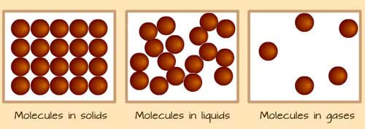
The particles in a solid are in fixed positions and are arranged in a regular pattern. In liquid and gas, the particles are not in fixed positions, hence a liquid and a gas flow.
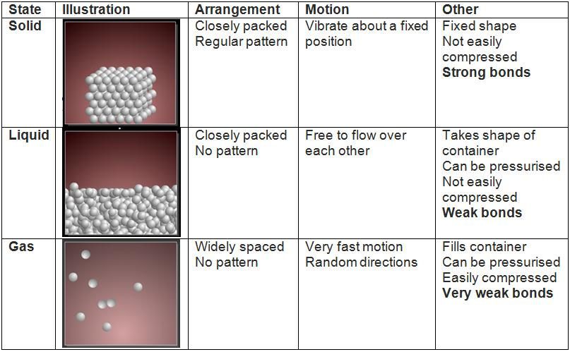
THE PARTICULATE NATURE OF MATTER
AIM: To show that matter is made up of tiny particles.
APPARATUS AND CHEMICALS
- A beaker . Sugar sucrose)
- Gras rod . Water
Procedure
- Put about 20${cm}^{3}$ of water in a clean beaker
- Add 1 tablespoonful of sugar.
- Stir the solution as shown in the figure below.

RESULTS
Sugar disappears because it has dissolved in the water. The sugar breaks down to tiny particles which we cannot see. These particles are distributed throughout the solution. The coffee will also break down to tiny particles which will also be distributed throughout the solution. The solution will be coloured black.
Other colured substances can used to show the distribution of particles in water as shown in the experiment below
EXPERIMENT
Aim : To investigate movement of colour (particles) in a liquid
Apparatus and chemicals
- Beaker
- Glass tube
- Potassium permanganate or blue copper (II) sulphate crystals
- Water
Procedure

- Put 30${cm}^{3}$ of water in a beaker.
- Place a crystal of potassium permanganate at the bottom of the beaker with the help of a glass tubing as shown in figure above.
- Close the end of the glass tubing with the index finger and remove the glass tubing.
- Leave the beaker undisturbed for an hour
- What do you observe?
RESULTS- The water slowly turns purple.
Explanation
Both the potassium permanganate crystal and water are made of particles. The purple colour of potassium permanganate spreads out because the particles leave the crystal and mix with water particles. They are distributed throughout the solution which eventually becomes purple.

The solute particles move throughout the liquid. This experiment shows that matter is made up of tiny particles. The potassium permanganate particles move slowly from the crystal into the water because they keep on colliding with water particles as they move, eventually becoming evenly distributed and colour of water turns purple. This is called diffusion.
EXPERIMENT
Aim: To show that gases consist of particles that move.
Apparatus and chemicals
- Gas jars
- Bromine
- Glass tubing
Procedure
- Using a pipette or glass tubing, place a drop of bromine into gas jar A as shown in figure below.
- Invert another gas jar B over jar A (see below)
- Wait for a few minutes. What do you observe? Bromine in a vacuum will spread very fast. Explain why?

RESULTS
Both gas jars will be filled with a red-brown colour. Air is colourles while bromide vapour is red-brown. It is also heavier than air.
When the jar of air, (B) is inverted over a jar of bromine, the red - brown colour spreads up into it. After a few minutes, the gas in both jars is red-brown.
Explanation/reason
The reason for this observation is that both air and bromine are made of tiny particles that are in motion. As they move, these particles collide with one another and with the walls of the jar. These collisions cause the particles to change direction. Eventually they become every distributed hence the red-brown colour. This experiment shows that the gases are made up of particles. The particles of bromine diffuse from the lower gas jar where they are more concentrated to the upper jar they are less concentrated. This is also called diffusion. The smallest stable particle of matter is an atom. So matter is made up of atoms.
NB: An atom is the smallest stable particle of matter.
CHANGE OF STATE OF MATTER
Change of state occurs through either
- melting or freezing
- evaporating or condensation
Changes in temperature can cause a substance to change its physical state. Water can be a solid (ice), a liquid (water0 and a gas (vapour or steam). Its state can be changed by heating or cooling.

EXPERIMENT
Aim: To investigate what happens when ice is heated to boiling.

Apparatus and chemicals
- Beaker . Tripod stand
- Bunsen burner . Thermometer
- Wire gauze . Ice cubes
Procedure
- Arrange the apparatus as in figure below
- Place some ice in a beaker. Place a thermometer in the beaker containing the ice cubes and record the temperature.
- Warm the beaker and its contents gently as in figure (b). Note and record the temperature at which the ice changes to liquid water.
- Continue heating until water changes to vapour as shown in (c).
- Record the temperature at which bubbles appear.

- Describe your observation as you were heating ice to change into vapour. What conclusion do you draw from this experiment?
RESULTS AND EXPLANATION

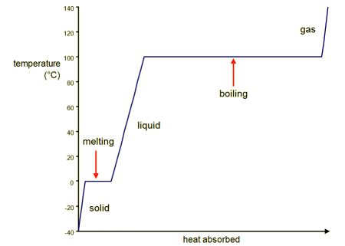
When ice is heated, its temperature rises steadily until it all changes to liquid. The change, its temperature rises steadily until it all changes to liquid. The change is called melting and this temperature is the melting point. It is $0^{0}$C for pure water. Therefore, melting is process whereby the solid changes from solid to liquid as shown below
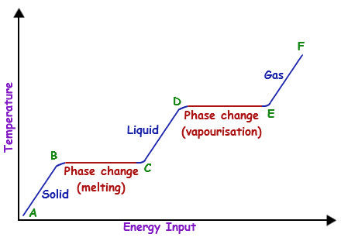
On further heating, the temperatures rises steadily, and some of the water changes to water vapour(or stem). The hotter the water gets, the quicker it evaporates and soon bubles appear. The change is now known as boiling and this temperature is known as boiling point of water. At sea level the boiling point of pure water is 100$°$C.
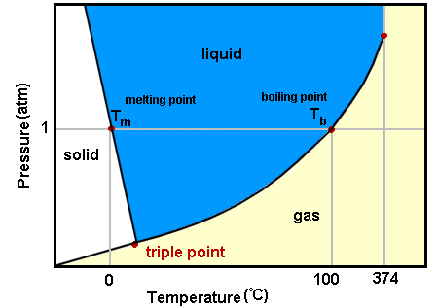
The change of state from solid (ice) to liquid (water) and then from liquid to gas (vapour) can be reversed by cooling. On cooling, the gas (vapour) can be reversed by cooling. On cooling, the gas changes into water.This process are called condensation.
On further cooling (to below (0$°$C) , the liquid changes into solid. The process is called freezing. The freezing point of water is the same as the melting point of ice (0$°$C) . All these can be represented as in figure below
Decreasing temperature
Melting Evaporation
Solid liquid gas
Freezing Condensation
0$°C$ (Melting point 100$°$ C (Boiling point)
Increasing temperature
CONCLUSION
We can conclude from the changes observed that something happens to cause changes in state of matter. The readings we note on the thermometer enable us to predict that the change in temperature must in a way be responsible for determining the state of matter.

Kinetic Theory
Kinetic theory assumes that matter is made up of extremely small particles in constant random motion.
CHANGE OF STATE AND KINETIC THEORY
Change of state involves heat energy being absorbed or given out. Kinetic theory explains the changes of state of matter.
Intermolecular forces of attraction
The figure below shows the arrangement of particles in thr three states of matter.
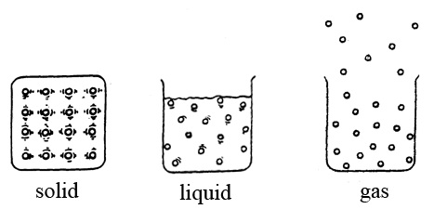
- (b) (c)
- solids
- Solids have strong forces of attraction between particles.
- Particles are held in fixed position by attractive forces.
- When solid is heated, the heat energy is gained by the particles. The extra energy makes the particles vibrate more and more, but within the same positions.
- Further heating weakens the forces of attraction between the particles even more and, the solid changes to liquid. This is melting.
- Liquids
- Liquids have moderate forces of attraction between particles.
- The particles are free to move randomly but tend to stick together. So, all liquids do not have definite shape and fill the bottom of any container in figure (a).
- Gases
- When a liquid is heated, the heat energy is gained by the particles and makes them move faster.
- The fast-moving particles at the surface overcome the forces of attraction from the other particles in the liquid and escape into the air. This is evaporation in (b).
- Particles in a liquid move randomly but stick together as shown in figure.

- Some particles overcome forces of attraction and escape into the air.

The above changes of state can be summarized as in figure shown below:

When the liquids get hot enough all the particles acquire enough energy and speed to overcome the forces of attraction between them and most escape from each other to the air.
During boiling, big bubbles of gas from inside the liquid as the particles, unlike in solids and liquids.
During condensation, the kinetic energy of the particles of gas is decreased. The particles come closer together, and the forces of attraction between them increase. A liquid is formed. This process is called `condensation.
Figure shows heating curve showing changes of state matter.

- A thermometer is used to measure temperature. Water freezes when the temperature drops to zero degrees Celsius. This can also be written as 0$°C$.This temperature is called the freezing point of water. Ice melts when the temperature of ice rises to $0°$ on a thermometer. So 0$°C$ is both freezing point and the melting point of water. This involves decreasing the kinetic energy of liquid particles even closer together and the forces of attraction between them increase, so that they vibrate within the same positions. A solid is formed. The process is called freezing. Therefore, freezing is the process of changing liquid to solid.
- The figure below shows the effects of heat on ice.

ELEMENTS, ATOMS MOLECULES, COMPOUNDS AND MIXTURES
EXPERIMENT
Aim: TO DISTINGUSH BETWEEN ELEMENTS, COMPOUNDS AND MIXTURES
Apparatus and chemicals Watch glass Splint
Iron filings Dilute hydrochloric acid Test-tube Magnate Sulphur powder
Procedure
- Mix some iron filings and sulphur powder in any proportion and place the mixture in a watch glass.
- Pass a magnet over the mixture and note what happens.
- Put half of the mixture in a test-tube, add water and shake. Does it dissolve?
- Allow the mixture to settle. How many layers can you see? Which is the bottom layer?
- Put the rest of the mixture in a test-tube and add a a few drops of dilute hydrochloric acid. Apply a burning splint. What do you observe?
- Now place a mixture of 7g of iron filings and 4 g of sulphur powder in a test-tube. Heat the bottom of the tube.

- When the mixture starts to glow, remove the flame and note that the glow starts to spread slowly through the mixture without further heating. Allow the product to cool, and then remove it.
- Note the colour of this product. Pass a magnate over it. Is there any attraction? To half of this product in a test-tube, add some water and shake. Is there any sign of separation?
- Put the rest of the product in a test-tube and add a few drops of dilute hydrochloric acid. Smell the gas produced cautiously. Describe the smell.
Observation from the experiment/results
- Before heating, the iron could be separated from sulphur by sedimentation or using a magnet. These are physical methods. These methods could not separate iron and sulphur after heating.
- Before heating, iron reacted with dilute hydrochloric acid to form a gas (that produces a “pop” sound with a burning splint). Sulpur was not affected. The product of heating iron and sulphur produced a gas with a punget smell 9rotten egg smell).
- The mixture of iron and sulphur was an average of grey 9for iron0 and yellow 9for sulphur0 before heating. After heating, the product has a dark grey almost black colour.
- In mixture iron and sulphur no heat was produced. But after heating the mixture, the formation of the new substance produced enough heat resulting in a bright red glow.
ELEMENTS
Define an element
An element is defined as a pure substance which cannot be split into anything simpler by any chemical process. For example iron and sulphur which form sulphide are elements.
CLASSIFICATION OF ELEMENTS
The two classifications of elements are
- Metals
- All metals except mercury are solids at room temperature.
- They are good conductors of electricity
- Non-metals
Graphite is a non-metal but is a good conductor of electricity.
EXAMPLES OF ELEMENTS
METALS |  | NON-METALS
Sodium | Magnesium | Carbon | Nitrogen
Calcium | Zinc | Silicon | Oxygen
Iron | Lead | Sulphur | Chlorine
Copper | Silver | Bromine | Iodine
Gold | Platinum | Fluorine | Hydrogen
Tin | Barium | Neon | Argon
Beryllium | Mercury | Boron | Phosphorus
Uranium | Cobalt | Helium | Graphite
Chromium | Manganese | Graphite is the only non-metal which is a good conductor of electricity.
Aluminum
Only mercury is only a metal which is solid at room temperature.
AN ATOM
Define an atom.
An atom is the smallest particle into which an element can be divided without losing the properties of the element.
NB: An atom of one element is different from an atom of another element. That means that an iron element is different from a copper atom. A copper atom is different from a zinc atom and so forth.
COMPOUNDS
Define a compound.
A compound is defined as a substance which is made up of two or more elements combined together by chemical means.
Therefore, a compound is a substance formed by chemically combining two or more elements together.
Example
When iron and sulphur are heated together, they combine chemically to form a new substance known as Iron (II) sulphide.
EXAMPLES OF COMPOUNDS
Name of a compound | Elements in the compound
Water | a compound of hydrogen and oxygen
Common salt | A compound of sodium and chlorine.
Copper carbonate | A compound of copper, carbon and oxygen
EXAMPLES OF COMPOUNDS AND THE ELEMENTS THAT THEY ARE MADE UP OF
Name of compound | Elements in the compounds
Magnesium oxide (white) | Magnesium - grey metal  Oxygen- colourless
Water(liquid at room temperature) | Hydrogen - colourless gas  Oxygen- colourless gas
Copper carbonate (green powder) | Copper- red-brown colour  Carbon- oxygen - colourless gas
Carbon monoxide (colourless gas) | Carbon -black solid  Oxygen - colourless gas
Copper(II)oxide (black powder) | Copper- red-brown metal  Oxygen- colourless gas
Copper(II)nitrate (green solid) | Copper-red-brown metal  Nitrogen - colourless gas  Oxygen- colourless gas.
CHEMICAL SYMBOLS OF ELEMENTS
- Names of elements are written in a shorthand form known as chemical symbols. This system of writing symbols uses letters taken from the name of the element.
- The symbol of an element consists of one or two letters. The first letter of a chemical symbol must always be a capital letter. The letters are not joined like in handwriting. They must be printed. These symbols are an international code
SOME ELEMENTS AND THEIR SYMBOLS
ELEMENT | CHEMICAL SYMBOL
Carbon | C
Hydrogen | H
Nitrogen | N
Oxygen | O
Phosphorus | P
Sulphur | S
Examples of elements whose chemical symbols use two letters from the English name of the element
Element | Symbol
Calcium | Ca
Cobalt | Co
Chlorine | Cl
Magnesium | Mg
Manganese | Mn
Examples of elements whose chemical symbols use one or two letters from the Latin name of the element
Element | Latin name | Chemical symbol
Potassium | Kalium | K
Sodium | Natrium | Na
Iron | Ferrum | Fe
Lead | Plumbum | Pb
Silver | Argentum | Ag
Copper | Cuprum | Cu
Mercury | Hydragyrum | Hg
Gold | Aurum | Au
NB: The students are not expected to learn the Latin names but to learn the symbols and read them in English. For instance, Cu is read as copper.
The symbol of each element represents one atom of that element. For instance
Mg represents one atom of magnesium
2 Mg represents two atoms of magnesium
MOLECULES
Define the term “molecule”
A molecule is the smallest particle of an element or a compound which normally exist in a free and separate state. This means that there are some elements whose molecules consist of one atom while others have two or more.
Define the following terms
- Monatomic molecules- These are molecules which are composed of one atom.
Examples include argon molecule and noble gases
- Diatomic molecules- These re molecules which are composed of two atoms.
Examples include oxygen molecule, hydrogen molecule and Nitrogen molecule.
- Triatomic molecules- These are molecules which are composed of three atoms.
Examples include water molecule and ozone molecule.
DETERMING TYPE AND NUMBER OF ATOMS IN CHEMICAL FORMULAE OF COMPOUNDS
A correct formula of a compound or substance shows the atoms present in the compound in their simplest ratio.
For example, the formula of copper (II) sulphate is Cu${SO}_{4}$. It contains 1 atom of copper, 1 atom of sulphur and 4 atoms of oxygen.
COMPOUNDS, THE TYPE AND THE NUMBER OF ATOMS THEY CONTAIN
Compound name | Formula | Atoms of elements present
Sodium chloride | NaCl | 1 Sodium atom(Na) and 1 Chloride(Cl)
Water | $H_{2}$0 | 2 Hydrogen atoms(H) and 1 oxygen atom(0)
Calcium | Ca${CO}_{3}$ | 1 Calcium (Ca), 1 Carbon(C) and 3 atoms of oxygen (O).
PURE SUBSTANCES
CRITERIA FOR PURITY
Melting points or boiling points are used to test the purity of a solid or liquid. A pure substance melts and boils at a definite, sharp temperature.
EXPERIMENT
AIM: TO DETERMINE THE MELTING POINT OF NAPHTHALENE
Apparatus and chemicals
A thermometer Stand and clamp Burner
Boiling tube A melting point tube Naphthalene
Beaker Stirrer Water
Camphor
The figure below shows apparatus for measuring the melting point of a solid.

- Set up the apparatus as in figure above.
- Using a rubber band, tie the thermometer and the melting -tube together.
- Place the thermometer and the tube in a water-bath and heat the water gently while stirring continuously.
- Note and record the temperature at which naphthalene melts.
- Repeat the experiment using a mixture of naphthalene and camphor (camphor is an impurity in this case).
- Record the temperatures results of melting Naphthalene and Naphthalene + camphor mixture. What effect does camphor have on melting point of naphthalene?
OBSERVATION/RESULTS
- When naphthalene is melting, the temperature stops rising. It will only rise again when all naphthalene has melted.
- Naphthalene as a single pure substance melts at 80$°$C. an impure substance melts over a range of temperature, not at a particular point.
- If a solid has a melting point above 100$°$C, an oil bath is used instead of a water bath. This makes it possible for melting points above 100$°$C to be measured.
- It is possible to follow the temperature of a solid before and after melting point. The results then be used to plot a graph and produce a heating curve as in figure below.

- The heating curve for naphthalene (b) The heating curve for impure naphthalene
Portion AB | Naphthalene absorbs heat energy and the temperature increases steadily.
Portion BC | Pure naphthalene changes its state from solid to liquid. The temperature stays constant at 80$°$C until all naphthalene melts. All the heat absorbed is used to change solid naphthalene into liquid therefore no temperature rise.
Portion CD | The liquid absorbs more heat energy. The temperature rises. It stops rising when the boiling point of the liquid is reached.
Note: The heating curve of the impure substance has no horizontal portion because impure substances melt over a range of temperatures.

EXPERIMENT
AIM: TO DETERMINE THE BOILING POINT OF PURE WATER
Apparatus and chemicals
Boiling tube Thermometer Burner
Stopper Stand and clamp Water
The figure below shows the apparatus for measuring boiling point of pure water.

Procedure
- Set up the apparatus as shown in the figure above.
- Put distilled water in a boiling tube and heat.
- Note and record the highest steady temperature reached on the thermometer.
- Repeat the procedure using ordinary water and salty water. Which one boils at a higher temperature, pure water or tap water?Explain.
EXPLANATIONS/RESULTS
The boiling point of pure ethanol can be determined in aa similar manner. But ethanol is gently heated to the boiling point using water bath instead of direct flame because ethanol is a volatile liquid and flammable and therefore can catch fire. The diagram below shows the apparatus for measuring boiling point of ethanol.

Ordinary water boils at a slightly higher temperature than distilled water because it contains dissolved substances. Salty water will boil at an even higher temperature because of the salt added. It will boil over a range of temperature because as water evaporates , the solution becomes more concentrated, and the boiling point slowly rises.
The boiling point of pure ethanol is 78$°$C. If it contains any impurities, it will boil at a slightly higher temperature.
From the previous experiments, we can see that impurities raise boiling points of liquids and lower melting points of solids. Therefore boiling points and melting points can be used to test purity of a substance.
Another method that can be used to test purity is chromatograpgy. A coloured substance, if pure, will give only one ring or spot on a chromatogram. If it contains impurities (other dyes), it will give several rings or spots, depending on the number of dyes present.
APPLICATION OF IMPURITIES
The effect of purities on melting point has been used in
- Extraction of metals
- Extraction of aluminum metal- The ore containing this metal must be melted first. It has a high melting point of about 2000$°$C. An impurity called cryolite is mixed with the ore before melting. This impurity lowers the melting to 850$°$C.
- Extraction of sodium- Calcium chloride is added to lower the melting point from 1465$°$C to 600$°$C.
- In countries which experience winter, crude salt is poured on the roads to lower the freezing point. This prevents ice from forming on the roads. Water freezes at 0$°$C. With some impurities like salt, it freezes at a lower temperature.
TYPES OF MIXTURES
The two types of mixtures are
- Homogenous (uniform mixture) is one in which the particles are not evenly distributed into each other for example common salt solution, milk among others.
- Heterogeneous mixture is one in which the particles are not evenly distributed into each other for example of common salt and sand.
Therefore there are different types of mixtures
- solid -liquid mixtures- These mixtures can be in solution form or suspension
- Solutions
When salt, sugar, potassium permanganate and copper (II) sulphate crystals dissolve in water, the particles of these solids spread throughout in the water and cannot be seen. The mixture formed is called a solution. Therefore, a solution is a uniform mixture of solids and liquids. It may be coloured or colourless.
The substance that dissolves is called solutes. In this case, salt, sugar and potassium permanganate are solutes. The liquid in which the solute dissolves is called a solvent. Water, in this case, is the solvent. When a substance is dissolved in water the solution is called an aqueous solution.
- Suspension
When flour is mixed with water, flour does not dissolve in water. Instead, particles of flour spread throughout water. Some particles of flour eventually stele at the bottom9sediment) of the beaker if it is left to stand for a long time. Particles which have not settled at the bottom form a suspension. They make a mixture cloudy. In muddy water, suspended soil particles make the water appear brown.
Note: Do not confuse suspension with a solution. Particles suspended in liquids can be seen but in solutions are invisible.
- Liquid - liquid mixtures- These mixtures can be miscible or immiscible.
Water + Ethanol or oil + kerosene
- When water is mixed with ethanol, ethanol mixes completely with water. Kerosene and oil also mix completely. In each of these examples, one is solute and the other is solvent. In the process of forming solution, ethanol and the water particles spread uniformly in each other to form a solution.
- Liquids that mix completely to form a solution are said to be miscible.
- Other examples of miscible liquids are beer, wine, vodka and whisky which are solutions of ethanol in water.
- Other liquids do not mix but form layers. Examples include water and kerosene, water and oil. Such liquids are said to be immiscible.
- Solid -solid mixtures
Some solids can also form uniform mixtures with each other. For instance, when some metals are heated together at high temperatures, they melt. Before solidifying, the liquid metals cam mix together. This is dissolving one metal in another. When such a mixture solidifies, it forms an alloy which is a uniform mixture of the metals.
Examples
- Brass - It is an alloy of copper and zinc
Copper + Zinc Brass
- Bronze- It is an alloy of copper and tin
Copper + Tin Bronze
- Gas-liquid mixtures
Some common examples are carbon dioxide dissolved in fizzy drinks for example soda, air (oxygen) dissolved in water for aquatic animals and plants.
- Gas-gas mixtures
Air is a mixture of several gases such as oxygen, carbon dioxide, water vapour and noble gases.
SOLUBLE AND INSOLUBLE & UNIVERSAL SOLVENT
- Water is a common solvent. It is sometimes called universal solvent because it dissolves many substances.
- Substances that dissolve in a specific liquid are said to be soluble in that particular liquid. If they do not dissolve, they are said to be insoluble. Insoluble substances finally settle at the bottom of the liquid.
- Solubility is the extent to which a solid dissolves in a liquid. This depends on many factors include temperature.
EXPERIMENT
AIM: TO INESTIGATE THE EFFECT OF TEMPERATURE ON SOLUBILITY
Apparatus
- Water
- Beaker
- Potassium nitrate
Procedure
- Add about 1OO${cm}^{3}$ of cold water in a beaker
- Add potassium nitrate a little time and stir
- Repeat until no more salt dissolves.
- Place the beaker with the solution on tripod and heater while stirring. What can you observe?
RESULTS & EXPLANATION
- When you added more salt and it dissolved the solution was unsaturated. The water dissolved more solid because it did not have enough salt particles. A solution which has dissolved enough solute in the presence of some undissolved solute at a given temperature is called a saturated solution. If a saturated solution is warmed, it usually dissolves more solute, that is, it becomes unsaturated. In other words, some solutes are more solute in hot water than in the cold solvents.
- The amount of substance which dissolves in a specified amount of solvent, for example 100${cm}^{3}$ water to form a saturated solution at any given temperature is known as its solubility.
Note: Solubility of a solid can be increased by raising the temperature or adding more solvent.
METHODS OF SEPARATING MIXTURES
The methods of separating mixtures of two or more substances depend on the physical properties of the substances which make up the mixture. These include solubility, density, boiling point, miscibility and others.
Three methods of separating an insoluble solid from a liquid are
- Decantation
- Filtration
- Evaporation
DECANTATION
EXPERIMENT
AIM: TO SEPARATE SAND FROM A MIXTURE OF SAND AND WATER
Apparatus
- Sand
- Beaker
- Water
Procedure
- Place some sand in a beaker
- Add water and stir
- Allow the sand to settle to the bottom of the beaker
- Pour off water as shown in figure below

RESULTS AND EXPLANATION
When the insoluble sand particles settle to the bottom of the beaker (sediment), the water can simply be poured off and sand is left in the beaker. This process is called decantation. However, in some cases, we cannot obtain all the water from the mixture by decanting.
FILTRATION
EXPERIMENT
AIM: TO SEPARATE SOIL FROM A MIXTURE OF SOIL AND WATER
Apparatus
- Beaker Filter paper Soil
- Conical flask Filter funnel Water Mixture
Procedure
- Fold a circular filter paper into two a semi-circle, then again to form a quadrant.
- Open the paper into a hollow cone.

- Wet the paper cone with a little water so that is sticks to the funnel.
- Place it inside a filter funnel. Place the funnel on a conical flask as shown below.

- Stir the mixture of soil and water with a glass rod and pour it into the filter paper cone. What happens to the mixture? Describe the contents of the filter paper and that of the conical flask.
RESULTS AND EXPLANATIONS
- The heavy soil particles will remain in the beaker.
- Filtration is generally a more useful method than decantation for separating insoluble solids from liquids.
- In filtration, both the solid and liquid can be obtained in one process. We use a porous type of paper called filter paper, which acts like a fine sieve, allowing the liquid to pass through but retaining solid particles. The liquid which passes through is called the filtrate and the solid remains on the filter paper is called the residue.
APPLICATION OF FILTRATION IN PURIFYING WATER
Filtration is important in the process of obtaining clean water in our homes. In this process water from a source is first stored in reservoirs where most of the solid particles settle out. It is then filtered through sand and gravel which trap smaller particles of mud and other suspended solids as shown in the figure below.

The filtered water is treated with chlorine to kill germs before being pumped for use in homes and industries.
EVAPORATION
EXPERIMENT
AIM: TO SEPARATE SAND FROM SALT
Apparatus and chemicals
Beaker Filter funnel Glass rod
Tripod stand Salt Water
Conical flask Filter paper Wire gauze
Evaporating dish Sand
Procedure
- Place the mixture of salt and sand in a beaker.
- Fill the beaker half way with water.
- Stir with a glass rod to make the salt to dissolve faster as shown figure (a).
- Pour the mixture through a filter funnel fitted with a filter paper as shown in figure (b).
- Put the filtrate into an evaporating dish as shown in figure (c).
- Heat the filtrate gently and evaporate to dryness as shown in figures (c) and (d). What is the name of the white solid in the evaporating dish?

Caution: Do not taste unless instructed to do so by your teacher. Remember one of the safety rules- you do not taste anything in the laboratory unless asked to do so.
RESULTS AND EXPLANATIONS
This experiment has employed three techniques
- Dissolving
- Filtration
- Evaporation
- Sand was left on the filter paper as the residue. After evaporating all the water from the salt solution (filtrate), salt was left in the evaporating dish.
- The gaseous form of a substance at room temperature is called vapour. The process of changing a liquid to gas or vapour is called evaporation. Evaporation can be used to separate a dissolved solid (solute) from its solution.
- Evaporation is an essential process in drying wet clothes. During evaporation, only the solute is recovered while the solvent is let to escape as vapour. Evaporation takes place at any temperature.
SEPARATION OF IMMISCIBLE LIQUIDS
This can be done by either simple or fractional distillation.
EXPERIMENT
AIM: TO SEPARATE KEROSENE AND WATER USING A SEPARATING FUNNEL.
Apparatus Separating funnel Kerosene
Two beakers Water
Procedure
- Place the mixture of kerosene and water in a separating funnel.
- Leave the mixture for time until there is a clear dividing line between the two liquids.
- Remove the stopper and open the tap to let the lower layer run out slowly into a beaker. Close the tap when the upper layer reaches the tap.
- Run out a small quantity of the remaining liquid into a separate container and discard it.
- Using a different beaker, open the tap to let the upper layer run into it. The figure below shows an experiment to separate two immiscible liquids using a separating funnel.

Why should a small portion of the liquid between the first collection and the second one be discarded?
RESULTS & EXPLANATION
This discarded portion was a mixture of kerosene and water. The liquids that do not mix, such as kerosene and water, are said to be immiscible. Their separation is based on differences in their densities. The less dense liquid (kerosene) floats on the denser liquid (water). The device used is called a separating funnel.
SEPARATION OF SOLUBLE SOLID-LIQUID MIXTURES
This can be done using either simple distillation or fractional distillation.
SIMPLE DISTILLATION
EXPERIMENT
AIM: TO OBTAIN BOTH SALT AND WATER FROM A SALT SOLUTION USING SIMPLE DISTILLATION
Apparatus and chemicals
- Distillation flask
- Bunsen burner
- Thermometer
- Sodium chloride(common salt)
- Round bottomed flask
- Stand and clamp
- Beaker or conical flask
- Water

Procedure
- Prepares some salt solution
- First try to separate the components by filtration method. Does it works?
- Pour the solution into the flask and add pieces of broken porcelain as show below (3.38). Boil the solution.

- The residue solution can also be separated as shown bellow (3.39). What is the purpose of adding broken pieces of porcelain?

- What is the use of the thermometer in the experiment?
- Which of the two set-ups provides a better way of cooling the vapour? Explain. What do you think would happen if the direction of cooling water is reserved? Give a reason for your answer?
RESULTS & EXPLANATION
- The pieces of broken porcelain in the flask prevent “bumping” of the solution during boiling. Glass beads or pieces of porous pot can also be used to achieve smooth boiling.
- The thermometer is used for noting the temperature at which the solution boils. The set-up in the figure above is more efficient in cooling the vapour. This because of the cool water circulating in the condenser.
- If the direction of cooling water is reversed, the water circulating in the condenser would flow down through the condenser abit warm. Therefore it would both cool the vapour as efficiently as before.
- During simple distillation, evaporation and condensation take place at the same time but at different parts of the apparatus. The liquid is evaporated in the distillation flask. It is condensed by passing it through a condenser, which is cooled by water. The condensed liquid is transferred into a container usually referred to as a receiver. The pure liquid collected is called the distillate. This process is called simple distillation.
- NOTE: Simple distillation can also be used to separate miscible liquid mixtures whose components have a difference in their boiling points of 40 $°$C and above.
- In areas where the available water is salty, like in coastal regions, pure water can be obtained by distilling the salty water.
FRACTIONAL DISTILLATION
EXPERIMENT
AIM: TO SEPARATE A MIXTURE OF ETHANOL AND WATER BY FRACTIONAL DISTILLATION
Apparatus and chemicals:
Round-bottomed flask Bunsen burner Ethanol
Fractionating column Condenser Thermometer
Water Receiver
Procedure
- Set up the apparatus as shown in figure 3.40 above to separate a mixture of ethanol and water.
- The mixture is heated. At about 78$°$C ethanol whose boiling point is lower, (more volatile) begins to boil. Some water evaporates too, so a mixture of ethanol vapour and water rises up the fractionating column. When all ethanol has been separated the thermometer reading rises above 78$°$C.
- Continue heating and collect the liquid that drips between 80$°$C and 100$°$C in a different receiver and discard it. Why should we discard this portion?
- When the thermometer reading eventually rises to 100$°$C, the water is boiling and the liquid collected now is water. Collect it in another receiver.
- Perform the following tests on each of the two distillates.
- Smell each distillate
- Place a little of each on a watch glass and test with a lighted splint or match stick.
Figure below shows an experiment of separating a mixture of ethanol and water by fractional distillation.
- The fractionating column is packed with glass beads to increase the surface area for condensation. When the vapours rise, they condense on the glass beads in the column, which become hot.
- When the temperature of the beads reaches about 78 $°$C, ethanol vapour no longer condenses on them. Only the water vapour condenses. The water drips back to the lower parts of the column or into the distillation flask while the ethanol vapour enters the condenser. Ethanol condenses. Liquid ethanol drips into the receiver as the first distillate.
- The first distillate is flammable 0burns) and has a characteristic smell. This is ethanol (alcohol). The second distillate is not flammable and has no smell. It is water. .We have, therefore, separated the mixture into pure ethanol and pure water. The portion discard is a mixture of ethanol and water.
- Miscible liquids can be separated by fractional distillation especially if they have different, but close boiling points.
- Fractional distillation separates mixtures into two or more components or fractions.
USES OF FRACTIONAL DISTLLATION
Fractional distillation is used industrially or on large scale to
- Separate various fractions from crude oil
- Manufacture oxygen and nitrogen from air, for instance at the British Oxygen Company (BOC).
- Manufacture spirits such as gin and whisky
EXAMPLE OF FRACTIONAL DISTILLATION
Figure 3.41 shows an example of fractional distillation that is for separating crude oil in a refinery.
Fractional distillation is the process by which oil refineries separate oil into different more useful hydrocarbon products based on their relative weights in a distillation tower.
Fractional distillations happen inside a fractional column. At the bottom, it is hot and gets cooler towards the top. The crude oil is evaporated. Due to different boiling points, the vapours condense at different points in the fractional column.

SEPARATION OF SOLID -SOLID MIXTURES
Solid -solid mixtures can be separated using either
- sublimation or
- by use of a magnet or magnetism
SUBLIMATION
Sublimation is the process whereby substances change directly from solid to gas on heating and from gas to solid on cooling without passing the intermediate liquid state.
$solid \frac{Heat}{Cool} gas$
Examples of substances that sublime include
- Iodine
- Ammonium chloride
- Solid carbon dioxide/dry ice
Sublimation can be used to separate a mixture of two solids as long as one of the solids sublimes on heating.
EXPERIMENT
AIM: TO DEMONSTRATE SUBLIMATION
Apparatus and chemicals
Boiling tube Bunsen burner Flakes of iodine
Ammonium chloride Test tube holder or a strip of paper
Procedure
- Place a little ammonium chloride in a boiling tube.
- Hold the tube holder or a folded strip of paper.
- Hold the tube with a test tube holder or a folded strip paper.
- Heat gently over the non-luminous Bunsen flame and observe what happens.
- Repeat the experiment with one flake of iodine and record your observation.
RESULTS AND EXPLANATION
- Ammonium chloride does not melt. It turns into white fumes which condense back to a white solid on reaching the cooler parts of the boiling tube. The white solid is called a sublimate.
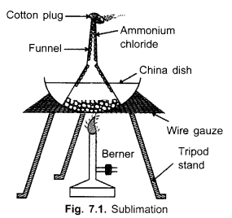
- Solid iodine forms purple vapour which condenses on the cooler parts to form a sublimate of pure iodine.
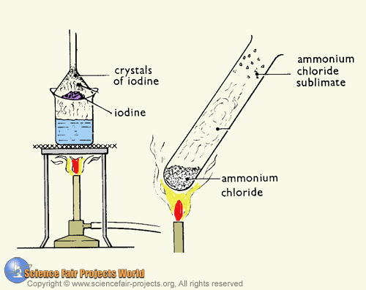
EXPERIMENT
AIM: TO SEPARATE A MIXTURE OF SODIUM CHLORIDE AND AMMONIUM CHLORIDE
Apparatus and chemicals
Burner
Sodium chloride
Funnel
Ammonium chloride
Procedure
- The apparatus is arranged as shown in the figure above.
- Mix equal amounts of common salt and ammonium chloride 9both salts are white and soluble in water).
- Place the mixture in an evaporating dish and cover with an inverted glass funnel. Why should we not use a plastic funnel?
- Heat the water to produce steam which in turn heats the mixture. Observe what happens.
- Repeat the experiment with a mixture of iodine and sodium chloride.
RESULTS & EXPLANATION
Ammonium chloride sublimes to form white fumes which cool to form a white solid on the inside surface of the funnel. Sodium chloride is left in the evaporating dish. Iodine also sublimes leaving the solid white sodium chloride behind.
Figure3.43 shows the results of an experiment used of separate sodium chloride and ammonium chloride
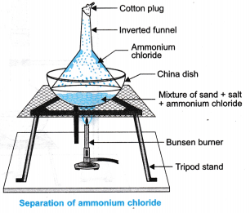
NOTE: We can also use a magnate to separate a mixture if it contains a magnetic substance. For example, in a mixture of iron and sulphur, iron will be attracted to a magnet.
MAGNETISM
It is a separation technique that involves the use of magnetic property. In industries an electromagnet is used to separate iron from other materials in the crushed ore. The electromagnet attracts iron, a magnetic substance from non-magnetic materials thereby achieving separation.
CHROMATOGRAPHY
Chromatography is a technique for the separation of components of a solution by passing it through medium. The components move at different rates over an absorbent material such as filter paper.
In paper chromatography, the absorbent is the filter paper and different solvents such as water, ethanol, propanone and other organic solvents can be used.
The main use of chromatography is separating the dyes for example, the dyes that make black inc. It is also used to analyse dyes in food colouring.

UNIT FOUR: ATOMIC STRUCTURE
Describe an atom.
- Atoms are very small particles of an element but they contain even smaller particles called sub-atomic particles.
- There are three kinds of sub-atomic particles which include:
- Protons - Protons are positively charge $\left(+ve\right)$ particles
- Electrons- Electrons are negatively charge $\left(-ve\right)$
- Neutrons - Neutrons have no charge
- Protons and neutrons are found in the nucleus.
- The nucleus is the middle part of the atom.
- Outside the nucleus is a much larger region of the atom where electrons occur in energy levels at different distances from the nucleus of the atom.
- Figure 4.1 is an atom that shows nucleus and a cloud of electrons.

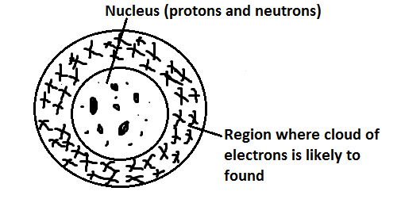
Figure 4.2 is nucleus of an atom that shows protons and neutrons.
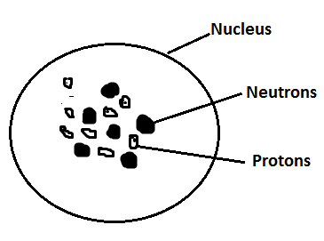
ATOMIC STRUCTURE
Figure 4.3 is the atomic structure that shows the nucleus and the electrons in the energy level.
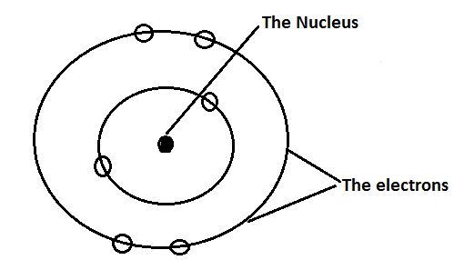
The Nucleus
- It is the centre of the atom
- It contains protons and neutrons
- It has a positive charge because of the protons
- The whole mass of the atom is concentrated in the nucleus.
- However, it is tiny compared to the size of the atom.
The electrons
- They move around the nucleus
- They are negatively charged
- They are tiny but cover a lot of space
- They occupy the energy levels
NEUTRAL ATOM
In a neutral atom, the number of protons is equal to the number of electrons. This means that each proton $\left(+ve\right)$ has an electron $\left(-ve\right)$ as a partner.
PARTICLES PRESENT IN ATOM
Sub-atomic particle | Mass | Charge | where found in an atom
Proton | 1 | + (positive) | Inside the nucleus
Neutron | 1 | 0(neutral) | Inside the nucleus
Electron | $$\frac{1}{1840}$$ | $-$ (negative) | Outside the nucleus.
ARRANGEMENT OF ELEMENTS IN SHELLS OF AN ATOM
- The various energy levels in an atom are represented by a series of circles sharing the same centre, separated from each other by roughly equal distances.
- The nucleus of atom is at the centre of the circle.
- The electrons in the energy levels are represented by ($θ$) or crosses $\left(×\right).$
- The energy levels are labeled 1st, 2nd, 3rd, 4th and so on starting from the one nearest to the nucleus as shown in figure 4.6.
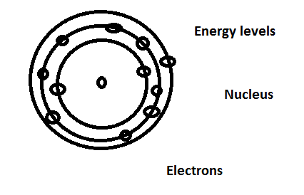
- The electrons that occupy the 1st energy level have lower energy than those in the 2nd energy level. Subsequently those in the 2nd energy level have lower energy than those in 3rd energy level and so on.
- The 1st energy level has a maximum of two electrons while the 2nd energy level has a maximum of eight (8) electrons. The maximum number of electrons that an energy level can hold is given by 2$n^{2}$. Where n= number of energy levels: 1st, 2nd 3rd among others. This means that when we draw the atomic structure; we should never put more than two electrons in the 1st energy level or more than 8 in the 2nd level. The third energy level is usually not full but can accommodate one to 8 electrons. (It holds a maximum of 8 electrons for the first 20 elements). The first 20 elements of the periodic table have 1 to 20 protons and 1 to 20 electrons.
Define the term electron configuration.
Electron configuration is the arrangement of electrons around the nucleus of an atom based on the energy level.
Write down the electron configuration of the following elements.
Element | Symbol | Number of protons | Electron configuration
Hydrogen | H | 1 | 1
Helium | He | 2 | 2
Lithium | Li | 3 | 2.1
Beryllium | Be | 4 | 2.2
Boron | B | 5 | 2.3
Carbon | C | 6 | 2.4
Nitrogen | N | 7 | 2.5
Oxygen | O | 8 | 2.6
Fluorine | F | 9 | 2.7
Neon | nE | 10 | 2.8
Sodium | Na | 11 | 2.8.1
Magnesium | MG | 12 | 2.8.2
Aluminum | AI | 13 | 2.8.3
Silicon | Si | 14 | 2.8.4
Phosphorus | P | 15 | 2.8.5
Sulphur | S | 16 | 2.8.6
Chlorine | CI | 17 | 2.8.7
Argon | Ar | 18 | 2.8.8
Potassium | K | 19 | 2.8.8.1
Calcium | Ca | 20 | 2.8.8.2
TABLE SHOWING THE ELECRON ARRANGEMENT OF THE FIRST 20 ELEMENTS
Element | Symbol | Number of protons | 1st energy level | 2nd energy level | 3rd energy level | 4th energy level | Electron arrangement
Hydrogen | H | 1 | $$∎$$ |  |  |  | 1
Helium | He | 2 | $$∎∎$$ |  |  |  | 2
Lithium | Li | 3 | $$∎∎$$ | $$∎$$ |  |  | 2.1
Beryllium | Be | 4 | $$∎∎$$ | $$∎∎$$ |  |  | 2.2
Boron | B | 5 | $$∎∎$$ | $$∎∎∎$$ |  |  | 2.3
Carbon | C | 6 | $$∎∎$$ | $$∎∎∎∎$$ |  |  | 2.4
Nitrogen | N | 7 | $$∎∎$$ | $$∎∎∎∎∎$$ |  |  | 2.5
Oxygen | O | 8 | $$∎∎$$ | $$∎∎∎∎∎∎$$ |  |  | 2.6
Fluorine | F | 9 | $$∎∎$$ | $$∎∎∎∎∎∎∎$$ |  |  | 2.7
Neon | nE | 10 | $$∎∎$$ | $$∎∎∎∎∎∎∎∎$$ |  |  | 2.8
Sodium | Na | 11 | $$∎∎$$ | $$∎∎∎∎∎∎∎∎$$ | $$∎$$ |  | 2.8.1
Magnesium | MG | 12 | $$∎∎$$ | $$∎∎∎∎∎∎∎∎$$ | $$∎∎$$ |  | 2.8.2
Aluminum | AI | 13 | $$∎∎$$ | $$∎∎∎∎∎∎∎∎$$ | $$∎∎∎$$ |  | 2.8.3
Silicon | Si | 14 | $$∎∎$$ | $$∎∎∎∎∎∎∎∎$$ | $$∎∎∎∎$$ |  | 2.8.4
Phosphorus | P | 15 | $$∎∎$$ | $$∎∎∎∎∎∎∎∎$$ | $$∎∎∎∎∎$$ |  | 2.8.5
Sulphur | S | 16 | $$∎∎$$ | $$∎∎∎∎∎∎∎∎$$ | $$∎∎∎∎∎∎$$ |  | 2.8.6
Chlorine | CI | 17 | $$∎∎$$ | $$∎∎∎∎∎∎∎∎$$ | $$∎∎∎∎∎∎∎$$ |  | 2.8.7
Argon | Ar | 18 | $$∎∎$$ | $$∎∎∎∎∎∎∎∎$$ | $$∎∎∎∎∎∎∎∎$$ |  | 2.8.8
Potassium | K | 19 | $$∎∎$$ | $$∎∎∎∎∎∎∎∎$$ | $$∎∎∎∎∎∎∎∎$$ | $$∎$$ | 2.8.8.1
Calcium | Ca | 20 | $$∎∎$$ | $$∎∎∎∎∎∎∎∎$$ | $$∎∎∎∎∎∎∎∎$$ | $$∎∎$$ | 2.8.8.2
Arrangement of electrons in an atom helps us to explain the patterns in properties of the elements.
An atom P has 12 protons. Write down the electron configuration of the atom.
In neutral atom, number of protons = number of electrons. This means that an atom P has 12 electrons since it has 12 protons.
Therefore, electron configuration of an element (atom) P is 2.8.2
Draw well-labeled diagrams to show electron configuration of the following atoms: hydrogen, helium. Lithium, fluorine, neon, sodium and chlorine atoms respectively
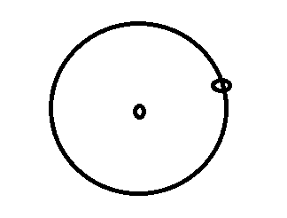
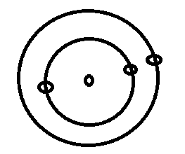

H I Li 2.1
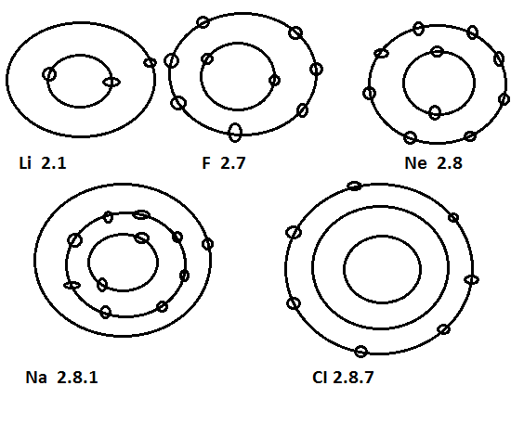
ATOMIC CHARACTERISTICS
THE ATOMIC NUMBER
- The atomic number tells us how many protons are there in a nucleus. It is denoted by letter Z. It also tells us the number of electrons in an atom.
- Therefore atomic number indicates that the number of protons in the nucleus of its atom is equal to the number of electrons in an atom.
THE MASS NUMBER
- The mass number is the sum of protons and neutrons in an atom. Therefore, it is always bigger than the atomic number.
- Mass number is denoted by letter A. Roughly the mass is double the atomic number.
- To get the number of neutrons, we just subtract the atomic number from the mass number that is A-Z.
Mass number (A) = number of protons + number of neutrons
A = Z + N
Calculation of Neutrons given mass number and atomic number
Neutrons = Mass number $-$ Atomic number
ATOMIC NUMBER AND ATOMIC MASS
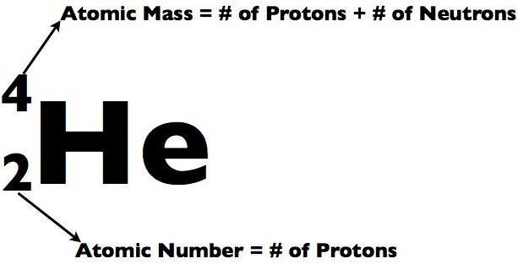
Draw the table that shows the relationship between the number of protons, neutrons and mass number of the following elements: Hydrogen, Carbon, Nitrogen, Sodium and Chlorine.
Mass number (A) = number of protons + number of neutrons
Neutrons = Mass number $-$ Atomic number
Atom | Symbol | Number of protons,  Atomic number | Neutrons | Mass number(A)
Hydrogen | H | 1 | 0 | 1
Carbon | C | 6 | 6 | 12
Nitrogen | N | 7 | 7 | 14
Sodium | Na | 11 | 12 | 23
Chlorine | Cl | 17 | 18 | 35
Example
Calculate the number of neutrons in a chlorine atom given that the atomic number, Z = 17 and mass number, A = 35.
The number of neutrons = A-Z
= 35-17
= 18
Therefore, a chlorine atom has 18 neutrons.
Remember: The number of protons and electrons are equal in an atom, once you know the atomic number which represents the number of protons; you automatically know the number of electrons in the atom.
EXAMPLE
A certain element X has atomic number 6 and mass number 14. Draw the atomic structure of element X showing all the sub-atomic particles and their numerical values.
The sub-atomic particles to show are protons, neutrons and electrons.
Atomic number = number of protons= number of electrons = 6
Number of neutrons = mass number- atomic number or A-Z
= 14-6=8
This means that we will show 6 protons and 8 neutrons in the nucleus. The 6 electrons will be indicated in the energy levels as shown in the figure below.
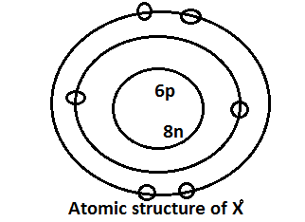

EXAMPLE
Draw the atomic structure of an atom Y showing the sub-atomic particles given the following information.
Atomic number, Z = 8
Mass number, A = 17
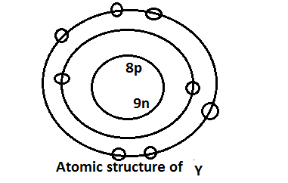

PRESENTATION OF MASS NUMBER & ATOMIC NUMBER OF ELEMENTS.
SUPERSCRIPT AND SUBSCRIPT
Usually, the atomic number, Z , and mass number , A, of an atom of an element are written alongside the symbol of that element, one as a superscript and the other as a subscript as shown below:
${}_{Atomic number Z}^{Mass number A}{ X Element}$
Note: The top number is referrred to as the superscript and bottom is the subscript.
So the symbol for an atom of sodium would be written as:
${}_{Atomic number 11}^{Mass number 23}{Na}$
We can also represent the sub-atomic particles using symbols with the mass of the particle as a superscript and the charge as a subscript as follows:
${}_{1}^{ Proton 1}P$
${}_{Neutron 0}^{1}n$
$${}_{Electron -1}^{0}e$$
An electron has zero mass and a charge of -1
ISOTOPES
Isotopes are atoms of the same element which have the same number of protons in the nucleus (atomic number) but different mass numbers.
EXAMPLES OF ELEMENTS WITH ISOTOPES
- Hydrogen
Hydrogen | Hydrogen$\left(99.99\%\right)$ | Deuterium$\left(0.01\%\right)$ | Tritium$\left(Trace\right)$
Symbols of Isotopes of hydrogen | ${}_{1}^{1}H$ | $${}_{1}^{2}H$$ | $${}_{1}^{3}H$$
No. of protons | 1 | 1 | 1
No. of neutrons | 0 | 1 | 2
No. of elections | 1 | 1 | 1
Mass number (p+n) | 1 | 2 | 3
- Carbon
Hydrogen | Carbon -12$\left(98.9\%\right)$ | Carbon -13$\left(1.1\%\right)$ | Carbon -14$\left(Trace\right)$
Symbols of Isotopes of carbon | ${}_{6}^{12}C$ | $${}_{6}^{13}C$$ | $${}_{6}^{14}C$$
No. of protons | 6 | 6 | 6
No. of neutrons | 6 | 7 | 8
No. of elections | 6 | 6 | 6
Mass number (p+n) | 12 | 13 | 14
- Chlorine
Chlorine | Chlorine$-35\left(75\%\right)$ | Chlorine$-37\left(25\%\right)$
Symbols of Isotopes of Chlorine | ${}_{17}^{35}{Cl}$ | $${}_{17}^{37}{Cl}$$
No. of protons | 17 | 17
No. of neutrons | 18 | 20
No. of elections | 17 | 17
Mass number (p+n) | 35 | 35
- Oxygen
Oxygen | Oxygen$-16\left(31.4\%\right)$ | Oxygen-17$\left(33.3\%\right)$ | Oxygen-18$\left(35.3\%\right)$
Symbols of Isotopes of hydrogen | ${}_{8}^{16}0$ | $${}_{8}^{17}0$$ | $${}_{8}^{18}0$$
No. of protons | 8 | 8 | 8
No. of neutrons | 8 | 9 | 10
No. of elections | 8 | 8 | 8
Mass number (p+n) | 16 | 17 | 18
The symbol for Lithium is${}_{3}^{7}{Li}$.
- What is the name given to the superscript (top number)?
- What is the name given to the sub subscript (bottom number)?
- Find the number of protons, neutrons and electrons in lithium atom.
The superscript (top number) is mass number.
The subscript (bottom number) is Atomic number.
The number of protons is 3, number of neutrons is 4 (7-3) and number of electrons is 3.
An atom of element X can be represented by the symbol${}_{6}^{16}X$.
State the
- Number of electrons of atom X.
- Mass number of X.
- Atomic number of X.
- There are 6 electrons in atom X (since there are 6 protons (atomic number) in X and protons are equal to electrons)
- Mass number is 16.
- Atomic number is 6
RELATIVE ATOMIC MASS OF AN ELEMENT
Relative Atomic Mass (R.A.M) of an element- It is the number of times the average mass of one of its atoms is greater than $\frac{1}{12}$ of the mass of one atom of carbon$-12$.
$A_{r}$ $=$ $\frac{Average mass of one atom of the element}{\frac{1}{12} ×mass of one atom of carbon -12}$
In 1961 the International Union of Puree and Applied Chemistry (IUPAC) recommended the most abundant of the carbon isotopes, carbon $-12\left({}_{6}^{12}C\right)$ as the standard reference atom. It has an abundance of 98.9%.
Nowadays, the atomic mass of an element is measured by comparing it with $\frac{1}{12}$ of the mass of one of a carbon atom$-12\left({}_{6}^{12}C\right)$.
One atom of ${}_{6}^{12}C$ isotope is taken to have a mass of 12.00 units.
$\frac{1}{12}$ of the mass of one atom of carbon $-12 =1.00$ units.
The proportions (abundance) in which the isotopes occur in an element may be stated as
- a ratio
- percentage of the total
- A fraction of the total.
Example
Suppose the sample contains 4 atoms of chlorine in the ratio 3: 1 respectively, then 3 atoms will each have a mass of 35 and 1 atom will have a mass of 37. Find the relative Atomic Mass.
The total mass of ${35}_{Cl}$ = 35 x 3
While the total mass of ${37}_{Cl}$ = 37 x 1
Therefore, the average mass of chlorine atoms will be :
= $\frac{Total mas of all atoms}{Total number of atoms}$
= $\frac{\left(35 x 3\right) + \left(37 x 1\right)}{4}$
= 26.25 + 9.25
The R.A.M = 35.5
Silicon $\left(Si=14\right)$ consists of three isotopes: silicon - 28, 92.2%, silicon -29, 4.7 % and silicon -30, 3.1%. Find the Relative Atomic Mass of silicon.
Percentage abundance simply means that if we have 100 atoms of an element called silicon, 92.2 atoms will each have a mass of 28.
Therefore, the total mass of these = $\frac{28 x 92.2}{100}$
= 25.81 atoms will be silicon -28
Therefore, the total mass of these = $\frac{29 x 4.7}{100}$
= 1.36 atoms will be silicon -29
Therefore, the total mass of these = $\frac{30.7}{100}$
=0.93 will be silicon -30
The total mass of all atoms = $\frac{28 x 92.2}{100}$ + $\frac{29 x 4.7}{100}$ + $\frac{30 x 3.1}{100}$
= 25.81 + 1.36 + 0.93
Therefore, R.A.M of silicon = 28.1
A sample of an element X consists of $\frac{9}{10}$ of ${}_{8}^{16}X$ AND $\frac{1}{10}$ of${}_{8}^{18}X$, show that the Relative Atomic Mass of X would be 16.2.
R.AM = $\left(16 x \frac{9}{10}\right)$ + $\left(18 x \frac{1}{10}\right)$
= 14.4 + 1.8
= 16.2
Copper has two isotopes in the following abundance ${}_{29}^{63}{Cu, 69\% }$and${}_{29}^{65}{Cu}$, 31%. Calculate the Relative Atomic Mass of copper.
R.AM = $\left(63 x \frac{69}{100}\right)$ + $\left(65 x \frac{31}{100}\right)$
= 43.47 + 20.15
= 63.62
An element X has the following isotope masses 54, 6%; 56, 92% and 57, 31%. Calculate the Relative Atomic Mass of X.
.RAM = $\left(54 x \frac{6}{100}\right)$ + $\left(56 x \frac{92}{100}\right)$ + $\left(57 x \frac{31}{100}\right)$
= 3.24 + 51.52 + 17.67
= 72.43
What do the following terms mean?
- Isotopes- Isotopes are atoms of the same element have the same number of protons and electrons in of their atom but have different numbers of neutrons in their nuclei.
- Mass number- Mass number is the sum of protons and neutrons.
- Atomic number- Atomic number refers to the number of protons in the nucleus of an atom.
- Atoms- Atoms are the smallest particles of an element.
- Protons- Protons are positively charged particles of an atom of an element.
- Electrons- Electrons are negatively charged particles of an atom of an element.
- Neutrons - Neutrons are particles of an atom of an element which have no charge.
- Relative Atomic Mass (R.A.M) of an element- It is the number of times the average mass of one of its atoms is greater than $\frac{1}{12}$ of the mass of one atom of carbon$-12$.

UNIT 5: THE PERIODIC TABLE
STRUCTURE OF THE PERIODIC TABLE
- Elements can be classified or grouped according to the number of electrons in the outer most shell. They can also be grouped according to the number of shells and such an array of elements is called a periodic table.
- The periodic table is organized as a grid. In the grid there are rows and columns. The periodic table has rows and columns.
- Elements are placed in specific columns because of the way they behave. They have similar chemical properties because they have the same number of electrons in their outer most energy level.
- In a periodic table, each of the rows is called a period. All the elements in the same period have the same number of energy levels. If we want to know in which period to find an element we count the number of energy levels. If it has 4 energy levels, it is in the 4th period.
- The two elements at the top row (the first period) have one energy level. All of the elements in the second row 9the second period) have two energy levels. The third row elements have three energy levels and so on.
- The diagram below shows periods in the Periodic Table.

- The Periodic Table has a special name for its column too. A column in the Periodic Table is called a Group. The elements in a Group have the same number of electrons in their outermost energy levels.
- The figure below shows the Groups in the Periodic Table.

- An element in the first column belongs to Group 1. It has one electron in its outermost energy level. An element in the second column belongs to Group II and has two electrons in the outermost energy level. The element in Group III has three electrons in the outer most energy level and so on. Therefore the Group number indicates the number of electrons in the outermost energy level.
PRINCIPAL CHARACTERISTICS OF THE PERIODIC TABLE
- The elements are arranged in an order which depends on one of their fundamental characteristics.
- The elements are divided into groups in such a way that similar elements lie in the same group.
- The elements within the same group will not necessarily have identical properties. But the way in which properties differ from one element to another (the gradation of properties) conforms to some pattern; so knowing the properties of one element in a group, it should be possible to predict the properties of another in the same group.
- Similarly, the gradation of properties from one group of elements to the next group of elements conforms to some position.
PERIODIC TABLE
Periodic table is a tabular arrangement of chemical elements in order of their atomic numbers and structure. It groups together elements with similar properties.
THE GENERAL STRUCTURE OF THE PERIODIC TABLE
- The elements are arranged in the order of the atomic number starting with hydrogen atomic number 1.
- The elements are divided into eight groups running vertically. Some groups of elements are given names:
Group I- the alkali metals
Group II- the alkaline earth metals
Group VII - the halogens.
Group VIII (O) - the noble gases.
- The three rows of elements forming the large block in the centre of the table are called the transition metals.
- The elements are also divided into periods which run horizontally. The number of elements in each complete period is significant.
Period 1 has 2 elements
Period 2 has 8 elements
Period 3 has 8 elements
Period 4 has 18 elements
Period 5 has 18 elements
Period 6 has 32 elements
Period 7 has 17 elements.
- Metals are on the left-hand side of each period. The properties of the elements in the group become more metallic as the atomic number increases (that is, down the group). While those to the right are non-metals. In between the two are special group of elements known as metalloids or semi-metals. This is because their properties are in between those of metals and those of non metals. Figure below shows the positions of these blocks of elements in the Periodic Table.

- Elements which are gases at room temperature and pressure are in the top right corner of the Periodic Table.
- The number of electrons in the outmost energy levels of any element is the same as the Group number of the Group containing the element, with an exception of the noble gas family.
- The most reactive elements are in Group 1, the most non-reactive elements are in Group VIII.
- The most reactive non metals are in the earlier periods, for example, fluorine is more reactive than chlorine. The most reactive metals are in later periods, for example potassium is more reactive than sodium.

ELECTRON CONFIGURATION AND THE PERIODIC TABLE
ELECTRON CONFIGURATION
Electron configuration refers to how the electrons are arranged in the energy levels of an atom.
Given the atomic number of an element, we can write the electron arrangement in shorthand.

EXAMPLE
The atomic numbers of X, Y and Z are 12, 13 and 14 respectively. Write the electron arrangement of each.
X 2.8.2
Y 2.8.3
Z 2.8.7
All the three elements are in period 3 because each has three energy levels. X is in group II, Y in Group III and Z in Group VII, following the number of electrons in their outermost energy levels.
ELECTRON ARRANGEMENT OF THE FIRST 20 ELEMENTS OF THE PERIODIC TABLE
The table below shows the arrangement of the first 20 elements of the Periodic Table.
- Hydrogen is a unique element. It is placed in Group I as its atoms have one electron in the outermost energy level. It also fits in Group VII because its atoms have one electron short of a fully filled outermost energy level.
- Helium is different from all other elements. It has two electrons in its single energy level which can accommodate a maximum of 2 electrons. Therefore, its outermost energy level is full and cannot accommodate extra electrons.
- The atomic number also gives you the number of electrons. The electronic configuration gives you the number of energy levels hence the period. The valence electrons in the outermost energy level give you the group of the element.
- The atomic structure diagrams below show how you can determine the Group number and the period of an element given the atomic number.
- Hydrogen
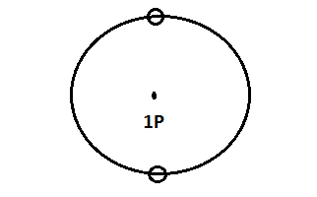
- Atomic number 1
- Electronic configuration 1
- Group 1
- Period 1
- Helium
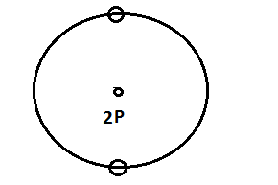
Atomic number is 2
Electronic configuration = 2
Group VIII
Period 1
- Lithium
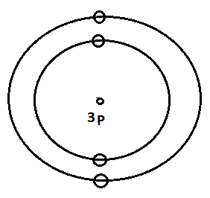
Atomic Number is 3
Electronic configuration is 2.1
Group 1
Period 2
- Fluorine
Atomic Number is 9 Group VII
Electronic configuration 2.7 Period 2
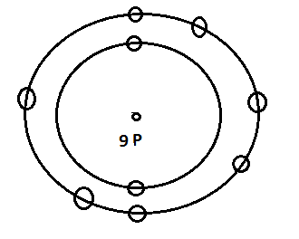
- Sodium
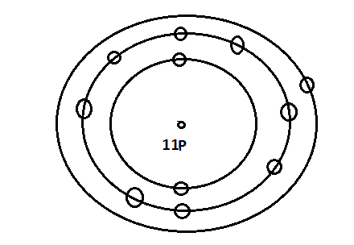
Atomic Number 11
Electronic configuration 2.8.1
Group I
Period 3
- Neon
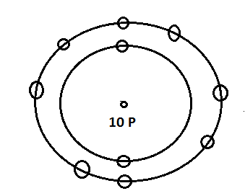
Atomic Number is 10
Electronic configuration is 2.8
Group 8
Period 2
FAMILY NAMES OF SOME ELEMENTS IN THE PERIODIC TABLE
Elements belonging to particular groups are given family names as follows
- Group 1 elements - Alkali metals
Examples of alkali metals are sodium, potassium and Lithium
- Group II Elements - Alkaline earth metals
Examples of alkaline earth metals are beryllium, magnesium and calcium
- Group II Elements - Halogens
Examples of halogens are fluorine, chlorine, bromine and iodine
- Group VIII Elements - Noble gases
Examples of noble gases are neon, argon and krypton.
The figure below shows family names of some elements in the Periodic Table:

UNIT 6: PHYSICAL AND CHEMICAL PROPERTIES
SAFETY RULES TO REMEMBER WHEN HEATING SUBSTANCES
- Ensure that the test tube or boiling tube is dry before use
- Make use of test tubes to heat solids, but, boiling tubes are preferred when boiling liquids or solutions. For large quantizes of liquids or solutions, beakers are preferred.
- Boil liquids or solutions; let the mouth of the test tube face away from your friends or books to avoid injuries in case of spurting.
- Always heat gently at first, holding the tube at an angle to the flame. From time to time, move the tube away from the frame.
- When heating solids, observe changes in colour or the colour of the gas being produce, listen out for sound too.
- If necessary, heat strongly and repeat the observation for smell and any other evidence for change.
- Always use a small non-luminous flame so that blackening of the glass does not occur.
DIFFERENCES BETWEEN PHYSICAL AND CHEMICAL CHANGES
Physical Change | Chemical Change
- No new substance is formed | A new substance is formed
- No energy is either given out or absorbed | Energy is usually given out or absorbed
- The mass of the substance does not change | The mass of the substance changes
- The change is usually reversible | The change is usually irreversible
PHYSICAL CHANGES
What can you observe when the following substances are heated?
- Wax
When wax is heated, it melts. On cooling, it solidifies to form the solid wax again.
- Iodine
Iodine forms a purple gas when heated. On cooling, the gas forms solid iodine again. Sublimation is the process whereby the solid changes directly to gas or changes directly from gas to solid.
- Sugar
Sugar dissolves in water. When water is evaporated, it is not easy to recover the sugar.
- Zinc oxide
Zinc oxide is a white solid when cold. When heated, it does not melt but just turns yellow. On cooling, it turns to the original white substance.
- Common salt
When common salt is shaken with water, it dissolves. When water is evaporated the salt sample is recovered.
In the above substances when they are heated, the changes which can take place are reversible. This means that the original substances. Changes like melting; boiling, evaporation and sublimation are reversible. They are called non-permanent of physical changes.
Some substances change colour when heated and regain their original colour when cooled.
- Hydrated Copper Sulphate
When copper$\left(II\right)$ sulphate is heated, a colourlessss liquid is given out, that is, water. It turns white anhydrous copper(II)sulphate blue
heat
Anhydrous cooper(II) sulphate Hydrated copper sulphate
water
Hydrated Copper (II) sulphate contains water molecules. Heat is used to drive the water molecules out of the crystals. This water is known as water of crystalisation. It is the one gives the crystals a blue colour. Without water of crystalisation, copper (II) sulphate is a white powder and it is said to be anhydrous copper (II) sulphate.
When we add water to anhydrous copper (II) sulphate, it turns blue, that is, becomes hydrated. The reaction takes place is as follows:
Anhydrous copper(II) slphate + water hydrated copper(II) sulphate
Hydrated copper(II) sulphate$\overset{heat (removes water)}{\begin{aligned} \\ Add water\end{aligned}}$anhydrous copper(II)sulphate

CHEMICAL CHANGES
HEATING MAGNESIUM
When magnesium is heated, it is burnt with a very bright dazzling flame. Magnesium forms white ash which is a new substance called magnesium oxide.
You cannot get magnesium from the oxide. It is an irreversible reaction. The reaction that takes place is as follows:
Magnesium + oxygen magnesium oxide
The substances formed are totally different from the original substances. This indicates that new substances are formed are burning. It is impossible to reverse the products formed to the original substances. The change that has taken place is permanent. Such changes are also called chemical changes or chemical reactions and are usually difficult to reverse.
Examples of chemical changes include
- Oxidation of food in our bodies
- Rusting of iron
- Burning of kerosene, petrol and charcoal

EXAMPLES OF EXCEPTIONAL REVERSIBLE CHEMICAL REACTIONS
heat
- Calcium carbonate calcium + carbon dioxide
This reaction can be reversed as follows
heat
Calcium + carbon dioxide calcium carbonate
heat
- Ammonium chloride ammonia + hydrogen chloride
This can be reversed as follows
Ammonia + hydrogen chloride ammonium chloride
NB: The plus sign(+) in chemistry when used in an equation means “reacts with” ( when used on the left side)
The arrow ( ) means to form the products on the right.
Where there is only one substances on the left as in the following equation:
Calcium carbonate calcium oxide + carbon dioxide.
This means when calcium carbonate is heated it decomposes (splits up) to form copper (II) oxide and carbon dioxide.
Two full-headed arrows mean it is reversible chemical reaction.
VALENCIES
Define the following terms
- Valency- It is the number of electrons an atom requires to attain the stable noble gas electron arrangement or it it is the combining power of the atom or group of atoms.
- Radical - refers to a group of atoms which occur in compounds but cannot exist on their own.
In other words, radicals refers to a group of atoms which usually behaves like it were a single unit in a chemical reaction for example sulphate, ${SO}_{4}^{2-}$ or hydroxide, ${OH}^{-}$
In metals, the valency is just the number of electrons in the outermost energy level. For non-metals it is the difference between Group VIII and Group number of the element, for example the valency of oxygen is 8-6 = 2.

What are valence electrons?
It refers to a single electron or one of two or more electrons in the outer shell of an atom that is responsible for the chemical properties of the atom.
VALENCIES OF OTHER COMMON ELEMENTS
Name of metal | Symbol | Valency
Zinc  Iron  Tin  Lead  Copper  Silver  Barium | Zn  Fe  Sn  Pb  Cu  Ag  Ba | 2  2 or 3  2 or 4  2 or 4  1 or 2  1  2
VALENCIES OF COMMON RADICALS
ammonium | $${NH}_{4}^{+}$$
Hydroxide | $${OH}_{}^{-}$$
Nitrate | $${NO}_{3}^{-}$$
Chloride | $${CI}_{}^{-}$$
Hydrogen carbonate | $${HCO}_{3}^{-}$$
Hydrogen sulphate | $${HSCO}_{4}^{-}$$
Carbonate | $${CO}_{3}^{2-}$$
Sulphate | $${SO}_{4}^{2-}$$
Sulphite | $${SO}_{3}^{2-}$$
Phosphate | $${PO}_{4}^{3-}$$
NB:
- Valency is the combining of an element or radical.
- Some elements have varying valencies, for example, copper can have valency of 1 or 2. The valencies are indicated in Roman numbers in brackets after the name of the element when naming compounds.

VALENCIES OF ELEMENTS IN COMPOUNDS
VALENCIES OF ELEMENT IN COMPOUNDS
Compound | Element | Valency
copper (I) oxide  copper (II) oxide  Iron (II) sulphate  Iron (III) chloride  sulphur (IV) oxide  sulphur trioxide  carbon (IV) oxide  carbon (II) oxide | copper  copper  Iron  Iron  sulphur  sulphur  carbon  carbon | 1  2  2  3  4  6  4  2

WRITING CHEMICAL FORMULAE
When writing the formula, metals are always written first. For example, it is not correct to write CINa or ${Br}_{2}$Ca even though it gives us the same information. The correct way is NaCI and Ca${Br}_{2}$ respectively.
Always remember that to write a correct formula we must write down the
- correct symbol of the element or radical
- correct valency of the symbol or radical
STEPS FOLLOWED WHEN WRITING THE FORMAULA FOR SODIUM SULPHATE

OTHER EXAMPLES
WRITING SIMPLE BALANCED CHEMICAL EQUATION
Chemical equations are short, clear and accurate descriptions of chemical reactions. A reaction process can be explained using an equation. for example, when oxygen reacts with magnesium ribbon, a white solid of magnesium oxide is formed. We have been using a word equation to describe such a reaction. Thus:
Magnesium + Oxygen magnesium oxide
The (+) sign hare is not used to mean addition, but in chemistry it is used to mean reacts with. The sign is used to indicate formation of a product. Using equal sign instead of arrow is wrong.
Names of starting substances like magnesium and oxygen in the above example are written on the left side of the arrow; these substances are called reactants. The new substances produced by the chemical reaction are called products and are written on the right side of the arrow.
Magnesium + Oxygen magnesium oxide
(Reactants) (Product)
Reactants refer to elements or compounds entering in a chemical reaction for example hydrogen and oxygen are reactants which form a product called water.
NOTATIONS
Chemical equations have various notations that indicate the physical state of the reactants and products. These notations are very important. In fact, whenever one writes an equation and misses to write them, the equation is not complete. These notations are as follows
State symbols
physical state | Representation of state | Description
solid  Liquid  Aqueous  Gas | (s  (l)  (aq)  (g) | a solid can be a precipitate or  suspension  a pure liquid like water and paraffin  a solute or liquid dissolved in water  a gas or vapour
Balancing chemical equations
In order for an equation to describe a reaction accurately, the equation must be balanced. Chemical reactions should always follow the law of conservation of mass so that the total mass of reactant must be equal to the total mass of products.
Reactants Products

Conservation of mass in a balanced chemical reaction
Let us consider our previous example of magnesium ribbon reacting with oxygen. We can write an initial equation containing the formula of reactants and products. Mg + O₂ Mgo
This equation is not balanced. Count the number of atoms of the reactant and the products.
Reactant | products
1 magnesium atom  2 oxygen atom | 1 magnesium  1 oxygen
The left side (reactant) has two oxygen atoms but the right side (product) has only one oxygen atom.

WAYS OF WRITING CHEMICAL EQUATIONS
Chemical equations can be written in two ways:
1. By using word equations
2. By using chemical symbols/formulae
WORD EQUATIONS
A word equation uses words to describe the reaction. In this equation you write the names of the reactants and products.
Examples are:
Magnesium + Oxygen Magnesium oxide
Sodium +Chlorine Sodium chloride
Calcium carbonate heat Calcium oxide + Carbon dioxide
CHEMICAL SYMBOLS/FORMULAE EQUATIONS
In this equation, you write the chemical formula of elements to show the reactants and products.
Example 1
Carbon reacts with oxygen to produce carbon dioxide. Write a chemical equation for this reaction using chemical formulae.
SOLUTION
C + O2 CO2
Example 2:
Magnesium reacts with chlorine to produce magnesium chloride. Write a chemical equation for this reaction using chemical symbols.
SOLUTION
Mg + Cl2 MgCl2
BALANCING CHEMICAL EQUATIONS
Balancing a chemical equation is the process of ensuring that the same number of atoms of each element is on either side of the equation.
GUIDELINES FOR BALANCING CHEMICAL EQUATIONS
  - Write the correct formulae for reactants and products.
  - Balance by multiplication of coefficients, not addition or subtraction of subscripts.
COEFFICIENT
This is a number that is written in front of a molecular formula. This number must be a whole number, not a fraction.
SUBSCRIPT
This is a lowered small digit. It is written slightly below the symbol of the element or atom.

- Write the physical states of the substance in the formula. The following are the short forms for different physical states which are commonly used in chemical equations.

Physical state | State symbol
solid state | (s)
liquid state | (l)
gaseous state | (g)
aqueous solution | (aq)

WORKED EXAMPLES ON BALANCING EQUATIONS
Example 1:
Balance the following equation:
H2 + O2 H2O
SOLUTION
Step 1:
Compare the number of atoms on the left hand side (L.H.S) and the right hand side (R.H.S).
Atom | Left Hand Side | Right Hand Side
Hydrogen (H) | 2 | 2
Oxygen (O) | 2 | 1

Step 2:
To make oxygen atoms equal, write numbers in front of the formula (H2). We can start with 2. If does not balance, we go to 3, 4 until the equation is balanced.
2H2 + O2 2H2O
When you have 2H2O, the number in front means that everything is multiplied by that number. Thus, there are two hydrogen molecules and two oxygen atoms.
Step 3:
Count the number of atoms of each element on the reactants and products, we find that the total number is the same.
 | Left Hand Side | Right Hand Side
Hydrogen (H) | 4 | 4
Oxygen (O) | 2 | 2
This means that the equation is now balanced.
Step 4:
Insert the correct state symbols for each substance.
2H2 (g) + O2 (g) 2H2O (l)
CALCULATING MASSES OF REACTANTS AND PRODUCTS IN CHEMICAL
REACTIONS
To calculate the masses of reactants or products of a reaction follow the following simple steps:
- Write a balanced equation for the reaction
- Use the balanced equation to come up with the relative atomic masses (RAMs) of each substance.
- Express the RAMs in grams.
- Use simple proportion to work out required masses.
Example 1:
Carbon reacts with oxygen to form carbon dioxide according to the equation below:
C (s) + O2 (g) CO2 (g)
(RAM of C = 12, O = 16)
Re-write the equation using masses.
SOLUTION
Mass of magnesium = (2 $×$ 24) g = 48 g
Mass of oxygen = (2 $×$ 16) g = 32 g
Mass of magnesium oxide = 2 $×$ (24 +16) g = 80 g
Thus: 48 g Mg + 32 g O 80 g MgO
- By proportion
48 g Mg = 32 g O
12 g Mg = y
y = $\frac{12g x 32 g}{48}$
= 8 g
Therefore, 8 g of oxygen is needed.
b. By proportion
48 g Mg = 80 g MgO
12 g Mg = x
x = $\frac{12g x 80g}{48g}$
= 20 g
Therefore, 20 g of magnesium oxide is produced
THE LAW OF CONSERVATION OF MATTER
The law states that matter is neither created nor destroyed in a chemical reaction. This statement means that in any chemical reaction, the total mass of the reactants is always equal to the total mass of the products. For example when hydrogen reacts with oxygen to
produce water:

UNIT 7: ORGANIC COMPOUND
Define the following terms
- Organic compound- An organic compound is a substance which may be natural or synthetic containing carbon as one of the elements for example petrol, ethanol, plastics etc
- Organic chemistry- It is the study of the compounds of carbon both of natural and synthetic origin.
- Hydrocarbons- These are organic compounds which contain carbon and hydrogen only. When burn in the air they form carbon dioxide and water. Examples such as petrol, diesel, kerosene, and liquid petroleum gas (LPG) etc and their derivatives
What are the natural sources of organic compounds?
- Plants and animals- These organisms synthesise many organic compounds. These include sugar, starch, fats, dyes, drugs among others.
- Petroleum- This is a fossil fuel which originates from dead organisms such as algae that is buried under rocks and has undergone chemical changes over millions of years.
- Natural gas- This is a hydrocarbon found underground on top of crude oil deposit. It is also found under the sea. Natural gas is 95% methane.
- Coal- This is a fossil fuel formed from decayed plant materials that has been subjected to heat and pressure over millions of years.
What is fuel?
Fuel is matter or substance that undergoes combustion readily and gives out heat energy.
What should be done for a fuel to produce heat energy?
Fuel must undergo combustion. Combustion of a substance requires oxygen. Actually, combustion is an oxidation reaction. During the process of combustion, energy is released. For example, when biogas (methane) is burned it produces carbon dioxide, water heat energy.
State the five substances used as fuels in homes.
- Solid fuel such as charcoal, wood , coal etc
- Liquid fuel such as petrol , kerosene, diesel, fuel oil, Alcohol (ethanol) and Methylated spirit (ethanol mixed with methanol in spirit lamps and stoves)
- Gas fuel such natural gas for example methane, liquid petroleum gas (LPG) for example propane and butane
- Biogas- Biogas (Methane) is also a by-product of the metabolism of some living organisms. In developing countries, such as India and china, farmers build digester.
A digester is an apparatus that makes methane from waste organic matter, such as animal cow dung. In the absence of air, bacteria feed and give off methane. The local people use the gas for heating and lighting. Such biogas systems are also being adopted in developed countries. They may provide a productive means of disposing of large amounts of waste from the intensive livestock farming.
- Liquefied alkanes - This is a convenient form of portable fuel supply. Butane, for example, is used in cigarette lighters camping stoves and lamps. Auto-mobiles and trucks can also be fueled by liquid alkanes. Such alkanes are called liquid petroleum gas (LPG) in automotive applications.
Composition and uses of fractions of petroleum
Petroleum is a mixture of compound which can be separated into fractions of different hydrocarbon by fraction distillation.
What is fractional distillation?
Fractional distillation is the method used to separate miscible liquids that have very close but different boiling points.
In other words, it is the process used to separate crude oil into its various components. The diagram below shows fractional distillation.
USES OF FRACTION OF PETROLEUM
Fraction | use
- Liquid petroleum gas (LPG) | - Fuel
- Petrol (gasoline) | - Powering vehicles
- Kerosene (paraffin) | - Jet fuel, heating and lighting
- Diesel | - Power heavy vehicles for example Lorries.
- Lubricants (for example lubricating oil or grease | - Reducing friction in moving parts of machines and vehicles.
- Bitumen | - Tarmacking road, repairing leaking roofs.

